shaped form.
DNA must be in chromosome form in order for the cell to divide or reproduce.

DNA is replicated in chromatin form to make two copies for cell division. Chromatin then changes to chromosomes in order for the cell to divide. When chromatin forms a chromosome, the chromosome appears as TWO identical joined replicates.

CHROMATID (SISTER CHROMATID): one of two duplicated, joined, identical parts of a chromosome; found after DNA replication but before cell division.
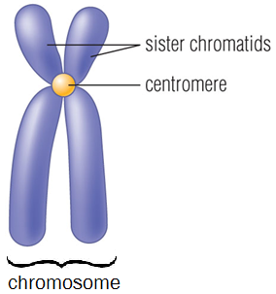
CENTROMERE: point at which sister chromatids are joined.

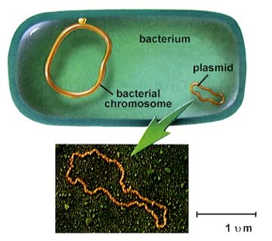
DNA in PROKARYOTES
- Bacterial DNA is circular
- Have 1 chromosome
- No nucleus, attached to cell membrane

