6:9 The Development of Gametes

SPERMATOGENSIS: the process by which males gametes form
OOGENESIS: the production, growth, and maturation of an egg, or ovum
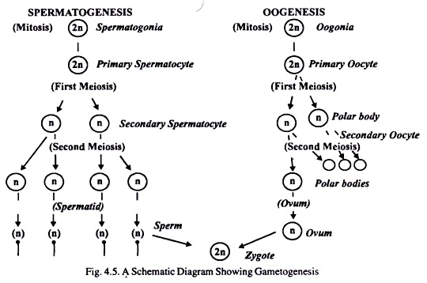

POLAR BODY: a short-lived product of the formation of gametes by meiosis

Steps of Sexual Reproduction
- Organisms produce GAMETES: haploid sex cells. Female gametes are eggs, male gametes are sperm.
- Egg and sperm unite forming ZYGOTE: diploid fertilized egg resulting from fusion of gametes, capable of developing into new organism.
- Zygote develops into mature organism by mitosis.
