Biology Name
Plant Structure and Reproduction Date/Hour

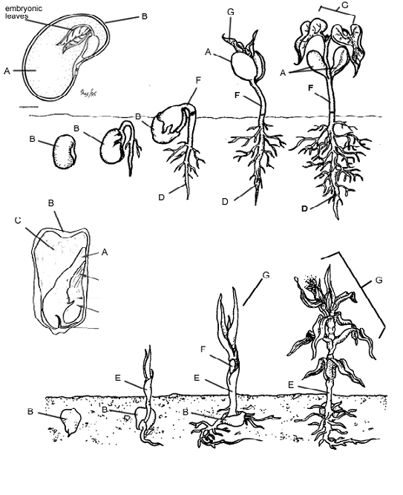
Comparing Monocots and Dicots

Angiosperms or flowering plants are divided into two classes, the monocots and the dicots. The majority of flowering plants are dicots. Dicots include maples, oaks, and magnolias. Monocots are grasses, wheat, corn, and rice. Most of our food supply comes from monocots. The diagram compares the differences between the two.

Both monocot and dicot seeds develop in similar ways and have the same parts. The major difference is that monocots start out with one seed leaf, while dicots have two. The technical word for seed leaf is cotyledon which is the first leaf to emerge from a developing seed. Color all the cotyledons (A) on the seeds dark green. As a seed, both monocots and dicots are covered by a seed coat. Color the seed coat (B) yellow.

The seed consists of the outside seed coat and a large area called the endosperm which functions as a source of reserve materials and food for the developing embryo. As germination occurs, the endosperm will be broken down and used by the plant. Color the endosperm blue (C).

Germination occurs when the seed begins to sprout, usually in the spring. Under appropriate conditions the radicle, the part of the seed that will become the root, begins to elongate and grow downward. Color the root brown (D). Meanwhile, the coleoptile begins to grow upward. The coleoptile is a sheath that encloses the shoot of the embryo. The primary function of the coleoptile is to provide protection to the developing shoot as it is passing through the soil. Color the coleoptile orange (E). Extending out from the coleoptile is the shoot. Shoots are new plant growth, they can include stems, flowering stems with flower buds, and leaves. The new growth from seed germination that grows upward is a shoot where leaves will develop. Color the shoot purple (F). Eventually adult leaves grow on the plant. Color these leaves light green. (G)

The root of a monocot is called a fibrous root and the root of a dicot is a taproot. Notice how taproots have one main part, called the primary root. In a taproot the primary root grows very large and small roots spread out from it. Fibrous roots, on the other hand, do not have very large primary roots, and many small roots develop and remain near the surface. Color the taproot dark brown and the fibrous root light brown.
Monocots and dicots also differ in their leaf structure. Adult monocots usually have parallel venation, whereas dicots have net-like venation. For monocots and dicots, color the leaves green and outline the veins in a darker green. The flowers of monocots and dicots differ in the number of petals they have. Monocots tend to have flower parts that occur in multiples of 3. Dicot flowers usually have 4 to 5 petals. Color the monocot flower purple, and the dicot flower pink. Stems hold the flowers up and attach the leaves, color the stems blue.

Monocot and dicots also differ in the way their vascular systems are arranged. In monocots, the vascular bundles are scattered throughout the stem. In dicots, the vascular bundles are arranged in a ring. Color the vascular bundles in both types of plants purple (V), color the stems green.

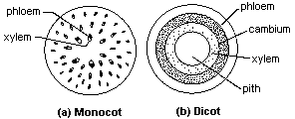
Trees and other vascular plants have a top and a bottom. The top has a trunk, branches, leaves, or needles. The bottom is a system of roots. Each needs the other to survive. The roots hold the plant steady and grab moisture and nutrients from the soil. The top is in the light, conducting photosynthesis and helping the plant reproduce. Xylem and phloem connect the two parts. Both xylem and phloem are vascular tissues found in a plant. Xylem is a tubular structure which is responsible for water transport from the roots towards all of the parts of the plant. Phloem is also a tubular structure but is responsible for the transportation of food and other nutrients needed by plant. Color the xylem blue and the phloem red.

Questions:
- Give two examples of plants that are monocots.
- Give two examples of plants that are dicots.
- What is a cotyledon?
- What is the radicle?
- What is the coleoptile?
- What is the function of the endosperm?
 | Number of Seed Leaves | Type of Leaf Venation | Number of Flower Parts | Type of Roots | Example
Monocot
Dicot
- Fill out the table below.
- An unknown plant is brought to you and your job is to determine whether it is a monocot or a dicot. You observe that the plant has 6 petals and its leaves have parallel veins. Is it a monocot or a dicot?
How do you know?
- Xylem carries , while phloem carries

Parts of the Flower
Flowers are the plant's reproductive structures. Angiosperms are types of plants that bear fruits and flowers. Flowers are usually both male and female and are brightly colored to attract insects to help them carry pollen used for sexual reproduction. Not all flowers are colorful, though. These flowers usually use the wind for pollination.
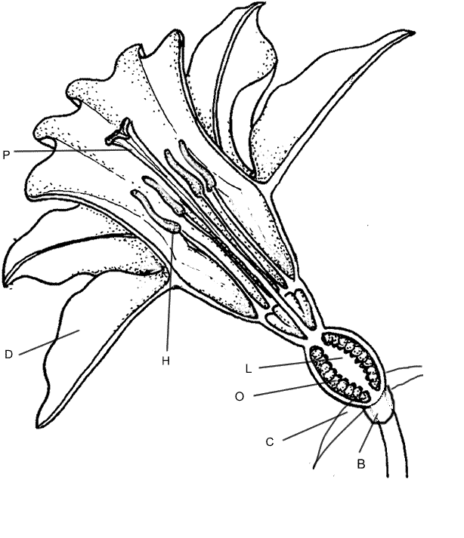
The receptacle is the part of the branch on which a flower forms. Color the receptacle (B) brown. Sepals are leaf like structures that surround and protect the flower before it blooms. Color the sepals (C) green. Petals are the colorful part of the flower that attracts insects and even other small animals, such as mice, birds, and bats. Color the petals (D) a bright color of your choice. All flowering plants have flowers, but some are not brightly colored. The petals of these flowers are reduced or absent and the plant relies on the wind or water for pollination.

The flower has both male and female reproductive parts. The female reproductive structures are called a pistil. Color the pistil (P) pink. The pistil has three parts, which can be seen, in the box labeled "pistil". The stigma at the top is often sticky and is where the pollen attaches. Color the stigma (J) purple. The style is the long tube that attaches the stigma to the ovary. Sperm from the pollen will travel down the style to the ovules. The ovules or eggs are stored in the ovary until they are fertilized. Plants can only fertilize eggs of the same species. Special chemicals prevent sperm from fertilizing the eggs of flowers that are not the same kind. Color the style (K) red, and the ovary (L) pink. Color the ovules (O) black.
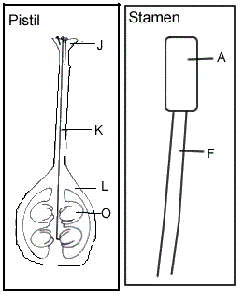
The male reproductive structures are called the stamens. Color the stamens (H) blue. Each stamen consists of an anther (A), which produces pollen, and a filament (F), which supports the anther. In the box labeled "stamen" color the anther dark blue and the filament light blue. Pollen produced by the anther is carried by insects or other animals to the pistil of another flower where it may fertilize the eggs.

Plant Reproduction
Sexual reproduction in plants occurs when the pollen from an anther is transferred to the stigma. Plants can fertilize themselves, called self-fertilization. Self-pollination occurs when the pollen from an anther fertilizes the eggs on the same flower. Cross-pollination occurs when the pollen is transferred to the stigma of an entirely different plant.

When the ovules are fertilized, they will develop into seeds. The petals of the flower fall off leaving only the ovary behind, which will develop into a fruit. There are many different kinds of fruits, including apples and oranges and peaches. A fruit is any structure that encloses and protects a seed, so fruits are also "helicopters" and acorns, and bean pods. When you eat a fruit, you are actually eating the ovary of the flower.

Questions
- What is an angiosperm?
- The flower attaches to what part of the plant?
- Why are flowers brightly colored?
- Name two mammals that might pollinate a plant.
- If the petals of a flower are reduced or absent, how is the plant pollinated?
- The female reproductive structures are called the
- Name the three parts of the pistil
- Where are the ovules stored?
- Name the two parts of the stamen
- Describe sexual reproduction in plants.
- The ovary develops into what structure?
- Define fruit.
- Some flowers are not brightly colored at all, but have a very pungent odor that smells like rotting meat. How do you think these flowers are pollinated?
- In many flowers, the pistils and stamens reach maturity at different times. Considering what you know about pollination, why would this be an advantage to the plant?

