Chloroplasts and Photosynthesis
Name: ____________________________ Date: _______________ Hour: ____________

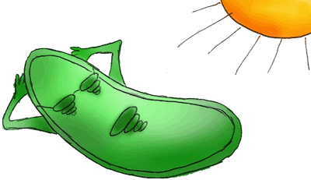
Review Plant Organelles
Plant cells have three kinds of structures that are not found in animal cells and that are extremely important to plant survival, plastids, central vacuoles, and cell walls. Plastids are organelles that, like mitochondria, are surrounded by a double membrane and contain their own DNA. There are several types of plastids, including chloroplasts, chromoplasts, and leucoplasts. Chloroplasts use light energy to make carbohydrates from carbon dioxide and water through the process of photosynthesis. Each chloroplast contains a system of flattened, membranous sacs called thylakoids. Thylakoids contain the green pigment chlorophyll, the main molecule that absorbs light and captures light energy for the cell. The thylakoids are connected and layered to form stacks called grana. Surrounding the grana is a solution called the stroma.

- What are the three structures found in plant cells that are not in animal cells? ________________________________________________________________________
- What is a plastid? __________________________________________________________
- Give three examples of plastids. ________________________________________________
- What organelle is involved in photosynthesis? ______________________________________

Chloroplasts
Plant cells and some Algae contain an organelle called the chloroplast. The chloroplast allows autotrophs like plants to harvest energy from sunlight to carry on a process known as Photosynthesis that is used to make their food. Specialized pigments in the chloroplast (including the common green pigment chlorophyll) absorb sunlight and use this energy to combine carbon dioxide and water and make GLUCOSE (simple sugar) and OXYGEN. The complete the chemical reaction for Photosynthesis is:

6 CO₂ + 6 H₂O + energy (from sunlight) C₆H₁₂O₆ + 6 O₂
Reactants ENERGY PRODUCTS

In this way, plant cells manufacture glucose (simple sugar) and other carbohydrates that they can store for later use. Photosynthetic cells found mainly in the leaves may have thousands of chloroplasts.

- What type of cells contains chloroplasts? _________________________________________
- What is the energy autotrophs use to make their own food? ___________________________
- The food making process is called _____________________________.
- What are the reactants for photosynthesis? _______________________________________
_________________________________________________________________________
- What simple sugar is produced by photosynthesis? ___________________________________
- What gas is USED? _________________________ RELEASED? _______________________
- Where are most photosynthetic cells in plants found? ________________________________
- About how many chloroplasts can be found in photosynthetic cells? ______________________

Chloroplasts are double membrane organelles with a smooth outer membrane and an inner membrane folded into disc-shaped sacs called thylakoids. Color and label the outer membrane of a single thylakoid light green. Thylakoids, mainly contain chlorophyll, the green pigment, but there are other accessory pigments also (red, orange, yellow, brown). Thylakoids are in stacks (like pancakes) called granum (grana, plural). Color and label one granum (STACKS) dark green in Figure 1.

Grana are connected to each other by structures called lamellae, and they are surrounded by a gel-like material called stroma. Color and label the lamellae brown in figure 1. Color and label the stroma light blue in Figure 1.

FIGURE 1-CHLOROPLAST
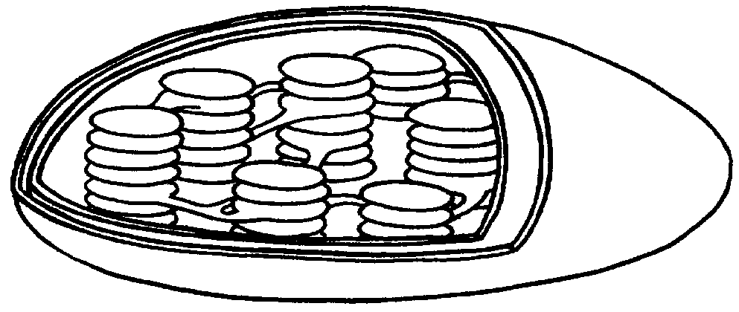

- How many membranes surround a chloroplast? ___________________________
- The outer membrane is S_______________.
- The INDIVIDUAL SACS formed by the inner membrane are called ________________________ and are arranged in ____________________ like pancakes.
- What main pigment is found inside a thylakoid? _____________________________________
- What color will it be? _____________________
- Other pigments that trap sunlight are called A_____________________ pigments. What colors are these pigments? _________________________________________
- STACKS of thylakoids are called G______________ (plural) or GRANUM (singular).
- Stacks of grana are connected to each other by _______________________.

Light-capturing pigments in the grana are organized into photosystems. On Figure 2, color and label a single thylakoid (SINGLE DISK) dark green. In figure 2, color and label a granum (STACK) red.
FIGURE 2-THYLAKOID
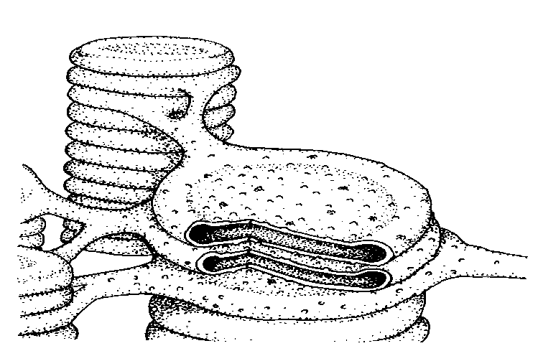

Overview of Photosynthesis

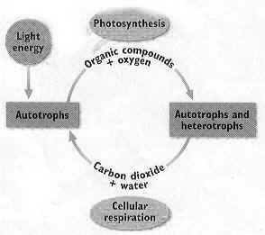
The figure to the right shows how autotrophs use photosynthesis to produce organic compounds from carbon dioxide and water. Remember that an autotroph is an organism that uses sunlight energy to make their own food. The oxygen and some of the organic compounds produced are then used by cells in a process called cellular respiration. During cellular respiration, carbon dioxide and water are produced. Thus, the products of photosynthesis are reactants in cellular respiration. Conversely, the products of cellular respiration are reactants in photosynthesis. Photosynthesis can be divided into two stages:
- Light Reactions-Light energy (absorbed from the sun) is converted to chemical energy, which is temporarily stored in ATP and the energy carrier molecule, NADPH.
- Calvin Cycle-Organic compounds are formed using carbon dioxide and the chemical energy stored in ATP and NADPH.

It is helpful to examine the two stages separately in order to better understand the overall process of photosynthesis.

- What is an autotroph? _______________________________________________________
_________________________________________________________________________
- What is USED in cellular respiration? ____________________________________________
- What is PRODUCED in cellular respiration? ________________________________________
- How are cellular respiration and photosynthesis related? ______________________________
__________________________________________________________________________________________________________________________________________________
- What are the two stages of photosynthesis? _______________________________________
- In the light reactions, ____________________ energy is converted to _______________________ energy.
- The chemical energy is temporarily stored in _____________________ and NADPH.
- What is NADPH? _______________________________________________
- What is formed during the Calvin Cycle? __________________________________________
- What is used to form the organic compounds? ______________________________________
_________________________________________________________________________

