Name: Date: Hour:
Instructions: Complete the practice worksheet by completing the desired elements of each question.
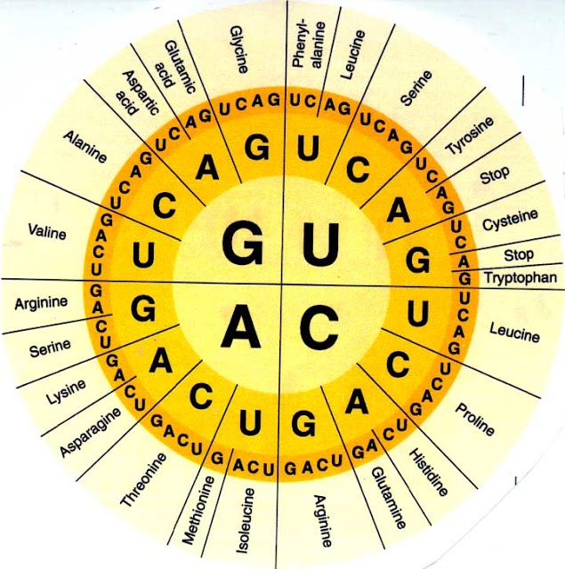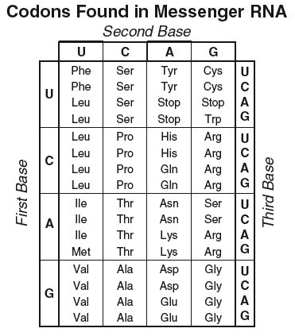
- Transcribe the corresponding mRNA strand from the given DNA strand:

DNA: TAC GCA CCC AGC CTA TCC GTC ATT
mRNA:

- Complete the corresponding DNA strand from the mRNA strand:

DNA:
mRNA: AUG ACU GCG CCC CGA UCC UGU UAA

- Translate the following mRNA sequence into its appropriate amino acid sequence: (abbreviate amino acids by first three letters. Example: Methionine abbreviates to MET

mRNA: AUG CUU AGC ACU GUU GAU UAU UCG
Amino Acids:
List all of the possible codon sequences for the following amino acids:
Met - Arg - STOP -

- Given the amino acid sequence, complete a possible DNA strand that compliments the strand:

DNA:
mRNA:
Amino Acids: Met – Lys – Pro – Arg – Ser – Leu - STOP

