**1959-***Jerome Lejeune* determines that Down’s Syndrome results from an extra chromosome—a total of three copies of chromosome 21.

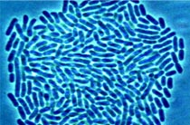

**1953-***James Watson* and *Francis Crick* describe the three-dimensional structure of DNA as a double helix: two spiraling strands held together by complimentary base pairs.

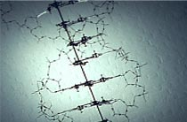

**1952-***Maurice Wilkins* and *Rosalind Franklin* take X-ray images of DNA crystals which will steer Watson and Crick toward their famous conclusions.

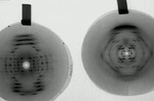

**1952-***Alfred Hersey and Martha Chase* show that viral DNA and not viral protein direct the replication of new viruses, confirming that DNA is the molecule that meditates heredity.

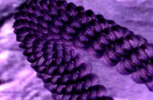

**1950-***Erwin Chargaff* shows there are equal amounts of the nucleotides adenine (A) and thymine (T) as well as equal amounts of guanine (G) and cyotisne (C), i.e. there is an A for every T and G for every C.

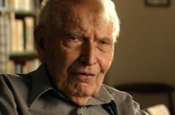

**1948-1949-***Linus Pauling* suggests sickle cell anemia is caused by a defect in the molecular structure of protein, and later describes the shape of certain proteins as an alpha helix. 