New genetic tools bring surprises about who is cousin to whom in the animal world.
Looks can be deceiving
By Dawn Stover
Popular Science January 1, 2002

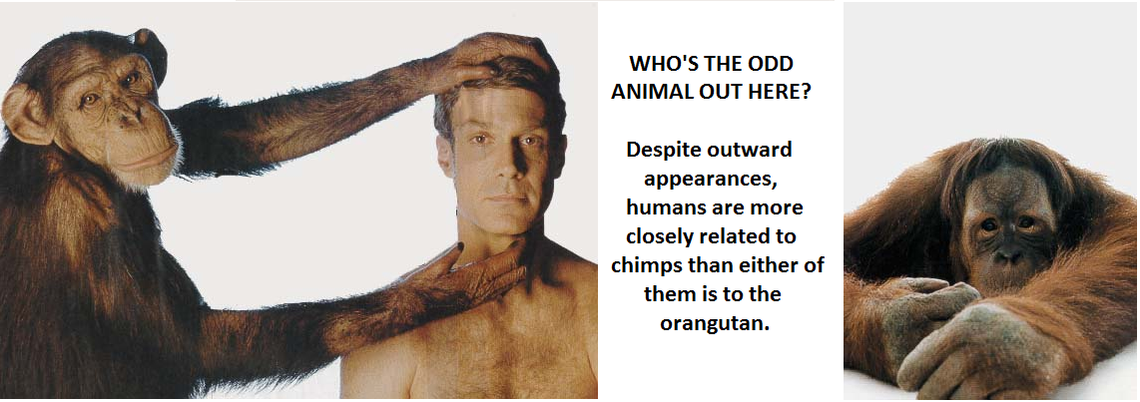If it looks like a duck, walks like a duck, and quacks like a duck, it is a duck, right? Not anymore, unless a DNA test says so.

Scientists at Pennsylvania State University and the University of Wisconsin recently used genetic evidence to prove that the duck-like grebe is actually more closely related to the exotic flamingo than to ducks. The finding defies common sense, because the flamingo and grebe don't look anything alike: One is long-legged and brightly colored, while the other is downright stocky and drab. What's more, the flamingo eats by filtering water through its beak while wading near shore; the grebe, meanwhile, catches a meal by diving for fish. "We haven't identified even a single trait that joins them together," says Blair Hedges, an evolutionary biologist at Penn State.

Such expressions of confusion are heard more and more often these days as biologists apply new genetic typing methods to animal classification and uncover a growing number of unexpected relationships. For instance, based on physical appearance alone--the centuries-old method that scientists have traditionally used to categorize animals--you would not expect to see a hippopotamus at a family reunion of whales, porpoises, and dolphins. But DNA studies indicate otherwise. The whales' ancestors, it turns out, are closely related to hippos, as well as to domestic livestock such as cows and sheep.

Even within our own animal family, looks can be deceiving. Zoologists long classified chimpanzees with orangutans and gorillas in a family called "the great apes," meanwhile granting humans a separate branch on the family tree. According to genetic analysis, though, more than 98 percent of human DNA is identical to chimpanzee DNA. In fact, chimpanzees are more closely related to humans than to orangutans and gorillas. "Humans are simply odd looking apes," psychologist Roger Fours of Central Washington University in Ellensburg, Washington, writes in his 1997 book, Next of Kin.

The excitement about using DNA analysis to redraw the tree of life is more than just an expression of taxonomists' compulsive need to classify. A precise accounting of who's related to whom would enable scientists to better understand evolution, combat invasive species, recognize emerging diseases, and create useful genetically engineered organisms, among other benefits. "Tracing the family tree will bear fruit in plant breeding, drug development, and many environmental challenges," National Science Foundation Director Rita Colwell said in a speech last year. "It's that proverbial library that enables much of genetic engineering--making possible the advances we read about each day."

The work of dividing animals into families, the field known as taxonomy, began in earnest with the 18th-century Swedish botanist Carolus Linnaeus. He introduced the naming system in which each type of living thing is classified as a species and then grouped with related species into a larger category known as a genus. The Linnaean system enabled scientists to catalog newly discovered plants and animals by their appearance.

Later scientists refined the system, going beyond superficial looks to examine an organism's morphology--its physical form and structure. Today's taxonomists conduct exhaustive physical examinations. They look at bones and teeth. They count scales, feathers, and petals. Most of the time, they do a pretty good job. "Comparative morphologists have been trying to explain patterns of similarity since the 1500s," says Quentin Wheeler, director of the Nation al Science Foundation's Division of Environmental Biology. "Most of the classifications have proven to be pretty accurate."

But these days, taxonomists also rely on newer techniques that make it possible to examine species at the genetic level. Two of these methods, DNA sequencing and DNA hybridization, were each used to show that the flamingo is the grebe's closest relative.

A DNA molecule is shaped like a zipper that has been twisted into a spiral. The zipper's teeth hold together because they consist of chemical pairs-represented by the letters A and T, C and G--that have a natural affinity for one another and thus bind together tightly.

A team of researchers led by Hedges at Penn State did the DNA sequencing work. DNA sequencing is simply a matter of determining the order of letters along key portions of the zipper for each of two species. The patterns are then compared to determine how many letters differ. The more that do, the further apart the species have drifted over time. In the case of the grebe and flamingo, that turned out to be not far at all.

The DNA sequencing results confirmed an earlier study led by John Kirsch, a zoology professor at the University of Wisconsin, involving DNA hybridization. This technique relies on the fact that unzipped strands of DNA yearn to bind to corresponding strands (because of the chemical affinity described earlier). An unzipped DNA strand will bind to the best partner it can find; but it will bind less intensely if its partner strand is not a close match. Scientists can determine how good such matches are by heating the DNA. The better matched two strands are, the more heat will be required to break them apart.
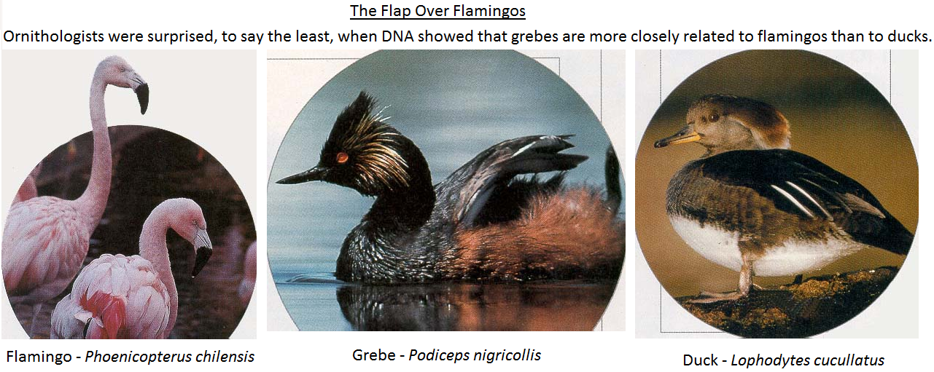
Kirsch and his colleagues began by heating the DNA of various bird species, causing the strands to unzip. Then they cooled the half-strands and mixed them together. After pairings naturally formed, the researchers heated the hybrid zippers to determine the temperature at which they would again unzip. The zippers consisting of DNA from both the flamingo and the grebe were the last to break apart. Since their DNA matched so well, the investigators knew the two birds must be closely related.

Kirsch was reluctant to publish his study because he didn't think anyone would believe the results, which went against the conventional wisdom about bird families. But once Hedges had obtained the same results using a different method, the two researchers decided to publish their findings jointly in the July 200l Proceedings of the Royal Society, a British science journal.

Some ornithologists find the conclusion sticks a bit in their craw. "It's surprising because nobody's ever thought of it before," says David Sibley, author of a renowned field guide, The Sibley Guide to Birds. "But I've been surprised by a lot of other things that have come out of DNA research. It's not far-fetched."

If the grebe and the flamingo are such close cousins, why do they look so different? The answer lies in divergence. That's a phenomenon in which related organisms evolve in different directions, sometimes quite rapidly. The grebe and flamingo, for example, may have adapted to different food sources in their environment.

The opposite can also happen. That is, organisms that are not closely related may develop similar traits over time--a phenomenon called convergence. For example, fish and whales developed similar shapes from living in water, but they belong to completely different animal families. In fact, whales are more closely related to hippopotamuses than to fish.

Scientists have long known that whales are related to hoofed mammals. But until recently, morphology and genetics disagreed on exactly who are the Whales closest land-dwelling relatives. DNA analysis seemed to indicate that primitive whales were closely related to an order of animals known as artiodactyls (which includes hippos, cows, sheep, pigs, camels, and deer). But studies of bone fragments from primitive whales led some scientists to conclude that these whales were more closely related to an extinct group of hoofed carnivores called mesonychids. Recently, scientists digging in Pakistan found well-preserved fossil whale bones that ay finally settle the argument. The new bones support the DNA studies concluding that primitive whales and hippos are cousins. Genetic studies continue to bring new relationships to light. In a project dubbed Deep Green, botanists led by Brent D. Mishler of the University of California, Berkeley, used genetic information to construct a relationship chart for green plants. This chart overturned the traditional view that land plants originally emerged from the sea, revealing instead that all green plants alive today are the descendants of primitive freshwater plants.

Deep Green is a mere footnote, however, compared with the National Science Foundation's expansive "tree of life" project. The foundation hopes to assemble a definitive relationship chart for all species--from microscopic bacteria to blue whales with hearts the size of Volkswagens. Biologists have been drawing limited family trees since the mid-1800s, but so far only about 50,000 of the 1.75 million known species have been placed on a tree, and scientists estimate that there are millions or even tens of millions of species yet to be discovered. Fitting so many living things into a single schema won't be easy; scientists say it's a "megascience" project far more ambitious than sequencing the human genome.

The impetus for creating such a comprehensive tree of life comes in part from the advent of DNA analysis--as well as another relatively new tool, the computer. But although the new genetic techniques are revolutionizing how taxonomy is done, they'll never replace the old-fashioned methods. DNA doesn't tell the whole story; careful anatomical comparisons are a crucial means of comparing one species to another. In fact, the National Science Foundation, concerned that bright young scientists are overly enamored with genetics, is spending millions of dollars to train them in traditional taxonomy. "The old methods are still vitally important for understanding biodiversity," says Hedges.

Heredity Name
Reading Questions Date/Hour
“Looks Can Be Deceiving”

Answer questions in full sentences.
- According to the article, to what other organism are whales closely related?
- Name the novel written by Mr. Roger Fouts.
- Which 18th century Swedish botanist began to classify organisms into groups?
- What field of Science did the botanist begin to develop?
- Explain his system of naming, known as binomial nomenclature.
- In what journal did Hedges publish his findings?
- Give two examples of artiodactyls.
- What project was led by Dr. Brent D. Mishler?
- Describe Dr. Mishler’s project.
- How many species have been classified since the 1800’s?

