Human Heredity Name
What is RNA? Date/Hour

- Below is a picture of the monomer of RNA, this would be referred to as a .
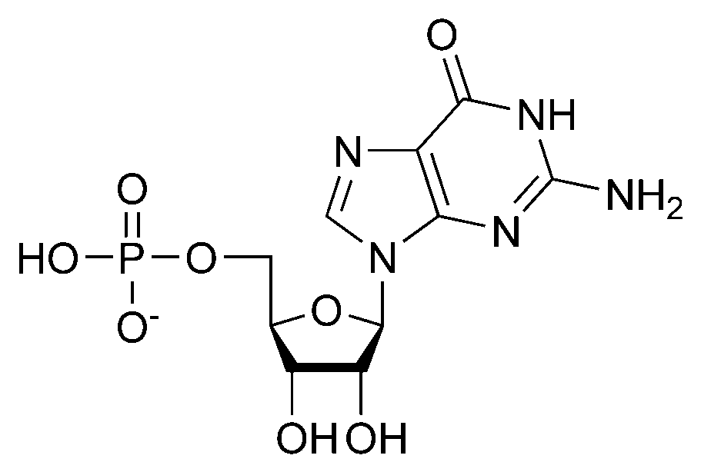
- In the picture above label the following parts – ribose sugar, base, and phosphate group.
- Explain three differences between RNA and DNA?

- The m in mRNA stands for . How does this relate to the function of mRNA?
- The t in tRNA stands for . How does this relate to the function of tRNA?
- The r in rRNA stands for . How does this relate to the function of rRNA?
- Where in the cell would you find DNA?
- Where in the cell would you find RNA?

