Why Twins?

Multiple births at the same time are rare for humans and most other primate species. Having fraternal twins apparently is a hereditary trait, having identical twins is not.
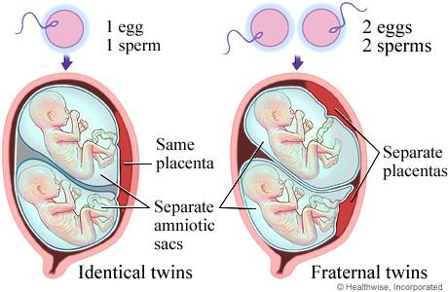
Fraternal Twins
- Fraternal twins may look similar but are not genetically identical. In fact they are no more alike than any siblings.
- They share their mother’s uterus during gestation, but come from two different eggs fertilized with different sperm.
- They are called dizygotic twins because the originated from two separate zygotes.

Identical Twins
- Identical twins are mostly identical genetically because they result from one zygote splitting into two or more separate ones within a few days after conception.
- They are called monozygotic twins because they originated from a single zygote.
- If the division of the original zygote does not occur until the 9th to the 12th day after conception, the monozygotic twins are likely to be mirror twins. That is, they will have small mirror image differences internally and externally. For instance, one may be left handed and the other right handed. Likewise, the cowlick in their hair at the back of the head will be on opposite sides.
- If the division of the zygote occurs after day 13, the monozygotic twins are likely to be born conjoined twins, which may be separated by surgery.
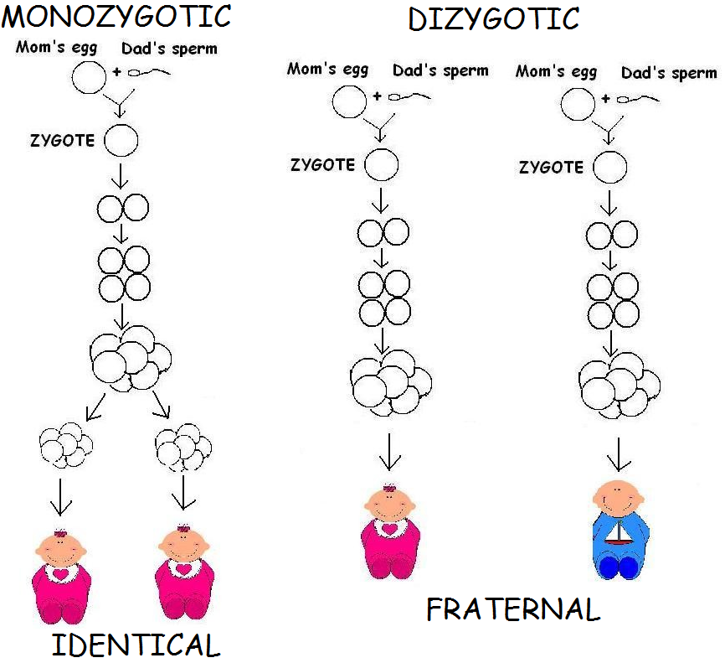
- Any differences between monozygotic twins later in life are mostly the result of developmental or environmental influences rather than genetic inheritance. For example, identical twins will not have the same fingerprints as those develop during gestation.
Why Twins Questions Name
Heredity Chapter 5 Date/Hour

True (+) or False (0)
1. Fraternal twins are genetically identical.
2. Dizygotic twins are also known as identical twins.
3. It is possible for fraternal twins to be of different gender.
4. Conjoined twins are a type of fraternal twins.
5. Fraternal twins share one placenta.
6. Dizygotic twins share the same placenta.
7. Fraternal twins are the result of the splitting of the pre-embryo early in cleavage.
8. All conjoined twins can be separated with surgery.
9. Identical twins will have identical fingerprints.
10. It is possible for fraternal twins to be “fathered” by different men.

Short Answer:
- Why are fraternal twins called dizygotic twins?
- Why are identical twins called monozygotic twins?

