3:7 Cellular Motility
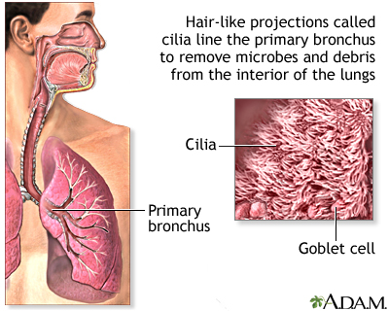
CILIUM: (cilia) short, hairlike cytoplasmic projections that line the cell membrane
Found on paramecium, on cells in the inner ear that vibrate and help detect sound, located along respiratory tube

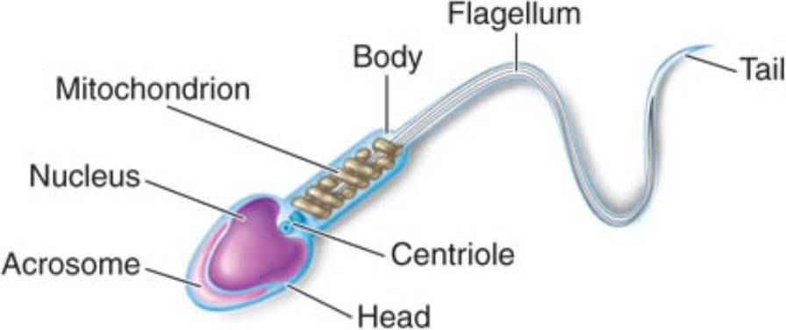
FLAGELLUM: (flagella) a long, hairlike structure that grows out of a cell and enables the cell to move
Many kinds of protists use flagella to propel themselves, as do human sperm cells

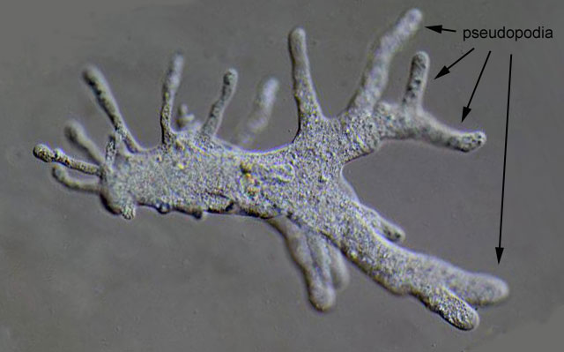
PSEUDOPODIUM: (pseudopodia) a retractable, temporary cytoplasmic extension
that functions in food ingestion and movement in certain amoeboid cells
A key characteristic of most protozoa

