4:3 General Nature of Photosynthesis

PHOTO-: light
-SYNTHESIS: to build complex from simple
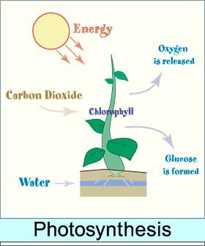

In photosynthesis, the simple substances are carbon dioxide (CO₂) and water (H₂O). The complex substance is glucose (C₆H₁₂O₆) with diatomic oxygen (O₂) as a byproduct.

Chemical Equation for Photosynthesis

light energy

6 CO₂ + 6 H₂O C₆H₁₂O₆ + 6 O₂
chlorophyll

This equation gives an overall view of what happens in a series of chemical reactions. PHOTOSYNTHESIS is much more complex.

CHLOROPHYLL: pigment found in all cells that carry out photosynthesis; inside the thylakoids of the chloroplasts

Two main types of chlorophyll: chlorophyll a (green pigment) and chlorophyll b (red, orange, yellow, brown).

CAROTENOIDS: pigments that are either red, orange, or yellow

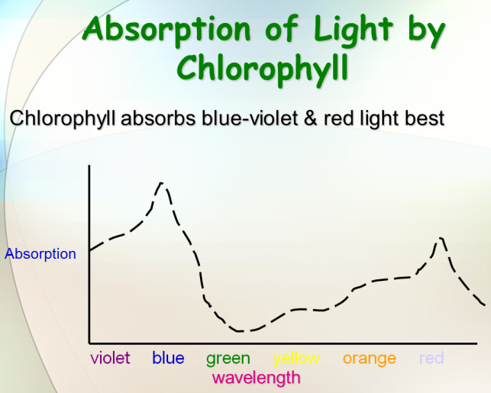
Chlorophyll a is directly involved in the light reactions of photosynthesis. Chlorophyll b assists chlorophyll a in capturing light energy, so it is considered an accessory pigment.

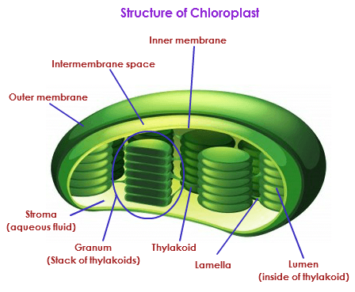

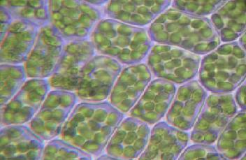

CHLOROPLAST: organelle in a plant cell where photosynthesis takes place

THYLAKOID: a membrane system found within chloroplasts that contains the components

STROMA: the solution that surrounds the thylakoids in a chloroplast

CHLOROPHYLL is a CATALYST in photosynthesis.

CATALYST: substance that affects the speed of a chemical reaction without entering into or being used up by the reaction
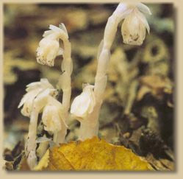
Chlorophyll cannot develop without light. Plants sprouted in total darkness will be yellow and unable to carry out photosynthesis.

