Biology Unit 5 DNA, RNA, and Protein Synthesis

5:1 History of DNA Discovery

Fredrick Griffith-conducted one of the first experiment’s in 1928 to suggest that bacteria are capable of transferring genetic information through a process known as transformation
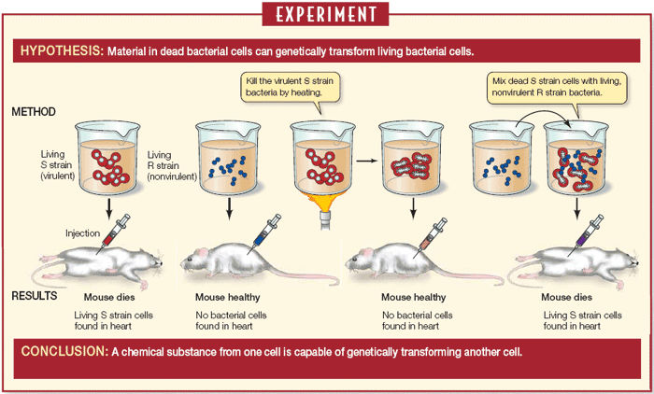

Oswald Avery-In the 1940s, tested whether the transforming agent in Griffith’s experiment was protein, RNA, or DNA. Also, concluded that DNA is responsible for transformation in bacteria

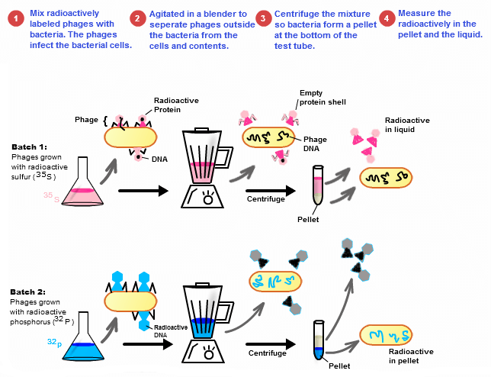
Martha Chase and Alfred Hershey-In 1952, tested whether DNA or protein was the hereditary material viruses transfer when viruses enter a bacterium
Discovered that DNA is the hereditary molecule in viruses
- Known as Blender Experiment

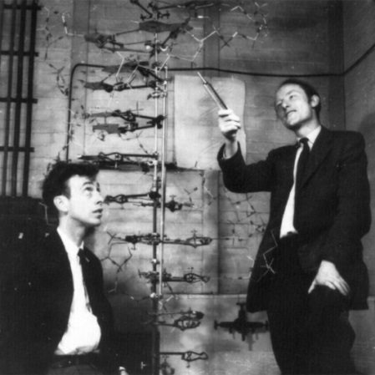
DNA Structure
James Watson and Francis Crick-In 1953, first to put together a model of DNArelied heavily on the work of other scientists to develop their model

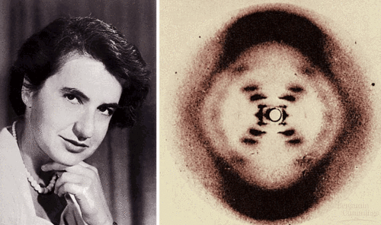
Rosalind Franklin-In 1952, used X-ray diffraction photographs of DNA crystals to show the structure of DNA

Erwin Chargaff showed the amounts of the four bases in DNA (A,T,C,G). In a body (somatic) cell:
- A=30.3%
- T=30.3%
- C=19.5%
- G=19.5%

Chargaff’s Rule: Adenine must pair with Thymine and Guanine must pair with Cytosine

