5:2 Introduction to DNA

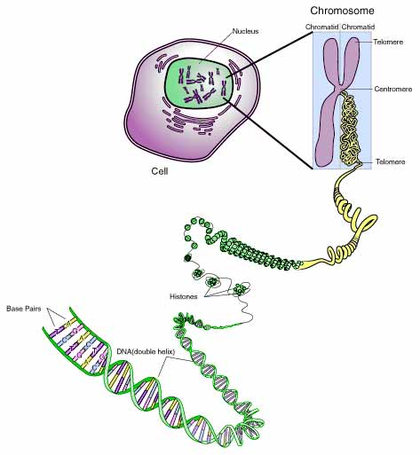
CHROMOSOMES: rod shaped form of genetic material in the cell nucleus that controls all cell activities through protein synthesis

Chromosomes and chromatin are the SAME material in different forms.
Chromosomes are a condensed, rod-shaped form found during cell division.
Chromatin is a long, thin thread-like form found when cells are not dividing.
Chromosomes & chromatin are made of DNA, a nucleic acid.

Chromosome Structure in Prokaryotes
- DNA molecule in bacteria is single circular
- Found in cytoplasm in the nucleoid region (no nucleus)
NUCLEIC ACIDS: complex biological compounds made of chains of nucleotides, serve as instructions for protein synthesis.

NUCLEOTIDE: 3 part units that make up nucleic acids, contain 1 sugar group, 1 phosphate group, and 1 nitrogen containing base

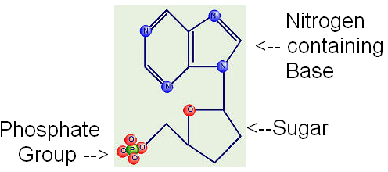

Nucleic acids are named for the sugar they contain.

DEOXYRIBONUCLEIC ACID: (DNA) nucleic acid that makes up chromosomes, controls protein synthesis and all other cell activities in all organisms

DEOXYRIBOSE: 5-carbon sugar in DNA

GENE: unit of heredity, enough DNA to instruct for the synthesis of one protein

DNAgeneschromatin/chromosomes

