5:4 DNA Replication

DNA has to be copied before a cell can divide.

New cells will need identical DNA strands.

REPLICATION: when DNA makes an exact copy of itself to be used when cells divide or to pass the code for making proteins to offspring

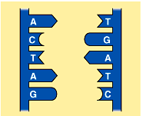
Steps of DNA Replication
- DNA unwinds from double helix and “unzips” (splits) down the center when bonds between the bases break by the enzyme Helicase.
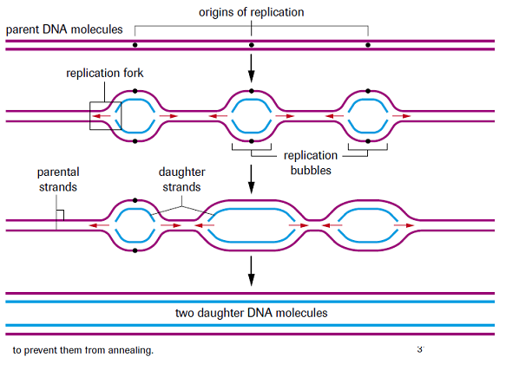
- A Single-Strand Binding protein attaches and keeps the 2 DNA strands separated and untwisted.
- As the 2 DNA strands open at the origin, Replication bubbles form
  - Prokaryotes have a SINGLE bubble
  - Eukaryotes have MANY bubbles
- Replication begins at the Origin of Replication, two strands open forming 2 Replication Forks

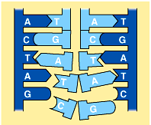
- Spare nucleotides move in and attach to their proper “old” bases using the enzyme DNA polymerase.

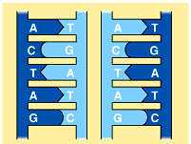

- Two identical DNA molecules are formed. In the new DNA strand, half is “old” and half is “new” in each.

Proofreading New DNA
- DNA polymerase initially makes about 1 in 10,000 base pairing errors
- The DNA Polymerase enzyme proofreads and corrects these mistakes
- The new error rate for DNA that has been proofread is 1 in 1 billion base pairing errors
