5:5 RNA

DNA always stays in the nucleus, but it must send the code for making proteins to the ribosomes in the cytoplasm.

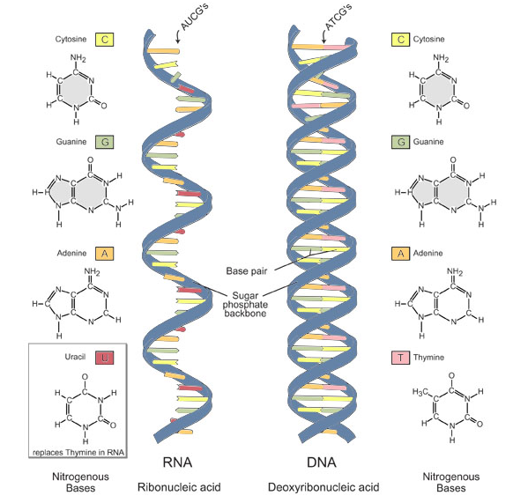
RIBONUCLEIC ACID: near copy of DNA that carries the code (or instructions) for protein synthesis from the nucleus to the cytoplasm

RNA differs from DNA
- Ribose is the sugar in RNA, deoxyribose is the sugar in DNA.
- RNA contains uracil where DNA contains thymine. In RNA uracil bonds to adenine.
- RNA is a single strand of nucleotides, DNA is a double strand of nucleotides.

Three Types of RNA
- MESSENGER RNA: (mRNA) copies DNA’s code and carries the genetic information to the ribosomes to perform protein synthesis
  - Long straight chain of 500-1000 nucleotides
  - Made in the nucleus
  - Copies DNA and leaves through nuclear pores
  - Contains A, G, C, U (no T)
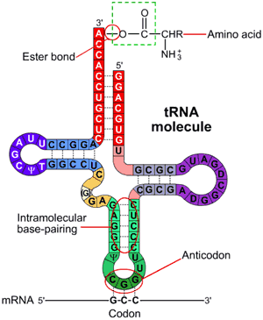
- TRANSFER RNA: (tRNA) transfers amino acids to the ribosomes where proteins are synthesized
  - Clover-leaf shape
  - Single stranded molecule with attachment site at one end for an amino acid
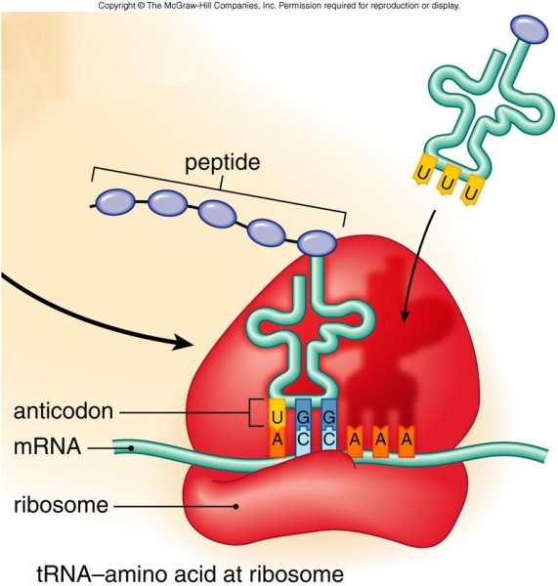
  - Opposite end has three nucleotide bases called ANTICODON: three nucleotides on the RNA that are complementary to the sequence of a codon in mRNA
- RIBOSOMAL RNA: (rRNA) globular form of RNA that makes up ribosomes, along with protein
  - Single strand 100-300 nucleotides long
  - Made inside the nucleus
  - Site of protein synthesis

