5:6 Transcription

Pathway to Making a Protein:
DNAmRNAtRNA (ribosomes)Protein

Protein Synthesis
Protein: organic molecules of which organisms are made
Synthesis: to make or build

PROTEIN SYNTHESIS: the process through which cells build the proteins they need and of which they are made

All cells carry out protein synthesis, each making their own proteins.
Each organism makes its own specific proteins; those proteins make an organism different from other organisms.
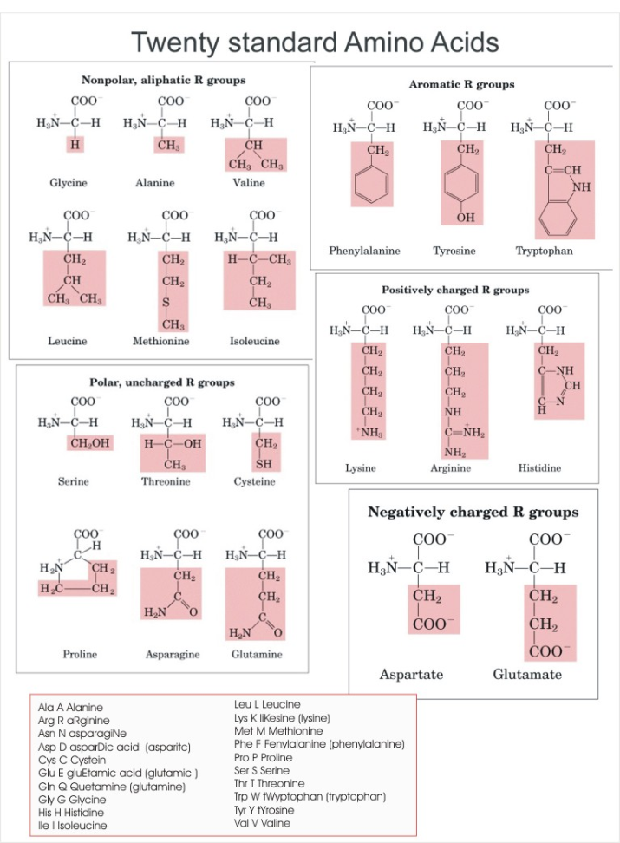
AMINO ACIDS: building blocks of proteins
Different combinations of amino acids different proteins

RIBOSOMES: site of protein synthesis in the cytoplasm of the cell

Ribosomes need instructions (BLUEPRINTS) to build the correct proteins. This chemical information (DNA) is passed from parent to offspring in chromosomes.

TRANSCRIPTION: the process through which a single strand of mRNA is produced from a DNA strand

Steps of Transcription
- RNA polymerase binds to the gene’s PROMOTER: a specific nucleotide sequence of DNA where transcription is initiated
The DNA strands unwind and separate.
- Complementary RNA nucleotides are added and then joined.

RNA DNA

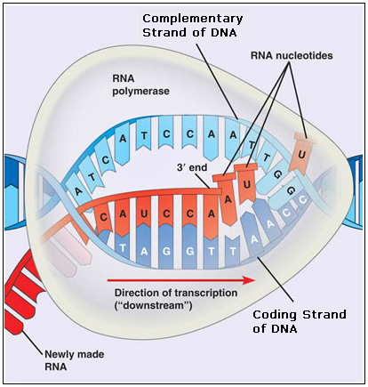
U bonds to A
A bonds to T
C bonds to G
G bonds to C

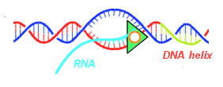
- When RNA polymerase reaches a termination signal in the DNA, the DNA and new RNA are released by the polymerase.

