2:8 Inorganic versus Organic

ORGANIC : from life

INORGANIC: not from life

INORGANIC COMPOUNDS: compound not a product of living organisms

Important Inorganic Compounds

1. OXYGEN(O2): needed to release energy from food through cellular respiration
2. CARBON DIOXIDE (CO2): needed for photosynthesis, supplies carbon to living things
   1. **exception: this inorganic compound contains a carbon atom**
3. 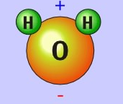WATER (H2O): most abundant inorganic compound, most abundant of all compounds in living things.

ORGANIC COMPOUNDS: carbon containing compounds manufactured by living things

Organic compounds may be represented by

* Molecular formula → CH4
* Structural formula→ H

H C H

H

FUNCTIONAL GROUPS: the portion of a molecule that is active in a chemical reaction and that determines the properties of many organic compounds

Common Functional Groups:

|  |  |  |
| --- | --- | --- |
| Functional Group | Structural Formula | Example |
| Hydroxyl | http://users.rcn.com/jkimball.ma.ultranet/BiologyPages/G/Groups_5.gif | http://sci-toys.com/ingredients/methanol.gif |
| Carboxyl | http://users.rcn.com/jkimball.ma.ultranet/BiologyPages/G/Groups_5.gif | http://chemwiki.ucdavis.edu/@api/deki/files/4434/image109.png?revision=1 |
| Amino | http://users.rcn.com/jkimball.ma.ultranet/BiologyPages/G/Groups_5.gif | http://wiki.chemprime.chemeddl.org/images/e/e9/Chapter_8_page_31-2.jpg |
| Phosphate | http://static.newworldencyclopedia.org/thumb/c/c4/Phosphate_Group.PNG/180px-Phosphate_Group.PNG | http://image.slidesharecdn.com/apbioch3newbookppt1-120927145832-phpapp02/95/ap-bio-ch-3-functional-groups-macromolecules-16-728.jpg?cb=1348765781 |

STRUCTURAL FORMULA: map of the atoms and bonds in a molecule

* Symbols represent atoms
* Lines represent bonds

– single bond – 1 pair e- shared

= double bond – 2 pairs e- shared

≡ triple bond – 3 pairs e- shared

STRUCTURAL FORMULAS ARE IMPORTANT BECAUSE many organic compounds have the same molecular formula and different structures.

BIOSYNTHESIS: manufacture of organic compounds by living things

2:9 Types of Large Carbon Molecules

MONOMERS: small, simple molecules

POLYMERS: monomers combined together to create more complex molecules

MACROMOLECULES: large polymers

1. Carbohydrates
2. Lipids
3. Proteins
4. Nucleic Acids

Order smallest to largest:

Monomers🡪Polymers🡪Macromolecules

2:10 Carbohydrates

CARBOHYDRATES: organic compounds made of carbon, hydrogen, and oxygen; H and O in a 2:1 ratio; examples: sugars, starches, cellulose

SUGARS: carbohydrates made by plants, provide fuel (energy) for living things

Two Types of Sugars

1. MONOSACCHARIDES: simple sugars containing carbon, hydrogen, and oxygen atoms in a 1:2:1 ratio; C6H12O6 or C5H10O5; examples - glucose, galactose, fructose.
2. DISACCHARIDES: two simple sugars combined; C12H22O11; examples - maltose, sucrose, lactose.

POLYSACCHARIDES: complex carbohydrates made of three or more simple sugars chemically combined; example - starches, cellulose.

DEHYDRATION SYNTHESIS: the formation of a large molecule by chemically combining 2 small molecules and removing a water molecule

C6H12O6 + C6H12O6 → C12H22O11 + H2O

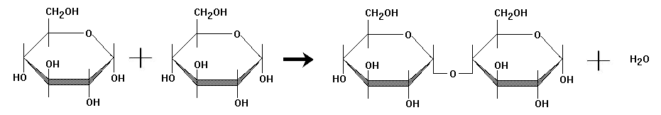

HYDROLYSIS: the chemical breakdown of a large molecule into small molecules by the addition of a water molecule

C12H22O11 + H2O → C6H12O6 + C6H12O6

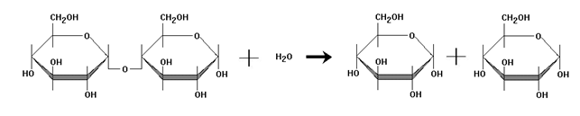

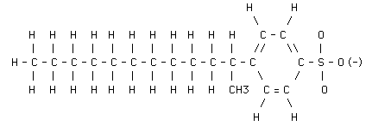2:11 Lipids and Proteins

LIPIDS: large, nonpolar organic molecules that store high amounts of energy

* Contain C, H, and O
* Made up of FATTY ACIDS: unbranched carbon chains that make up most lipids
* examples - fats, oils, waxes

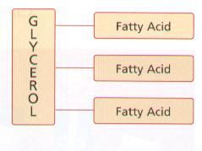

Three classes of lipids important to living things:

1. TRIGLYCERIDE: contains 3 fatty acid molecules and 1 glycerol molecule

|  |  |  |
| --- | --- | --- |
| DEFINITION | CHARACTERISTICS | EXAMPLES |
| SATURATED: composed of saturated fatty acids | * High melting point * Hard at room T° | http://creoleindc.typepad.com/.a/6a00d8341c5e0053ef0120a5d2d30a970c-800wi |
| UNSATURATED:  Composed of unsaturated fatty acids | * Soft or liquid at room T° | http://study.com/cimages/multimages/16/1unsaturatedfats.png |

1. 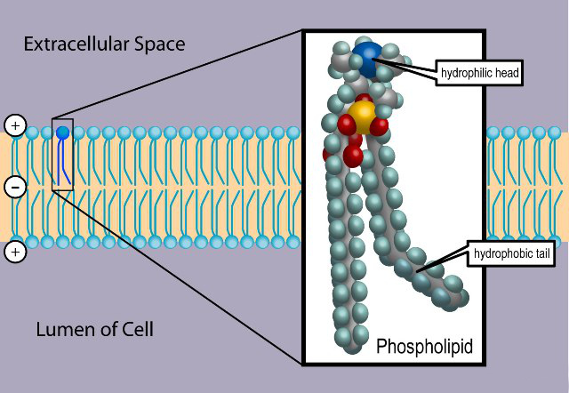PHOSPHOLIPIDS: have two, rather than three, fatty acids attached to a molecule of glycerol
   1. Example: Make the cell membrane
2. WAXES: type of structural lipid consisting of a long fatty-acid chain joined to a long alcohol chain
   1. 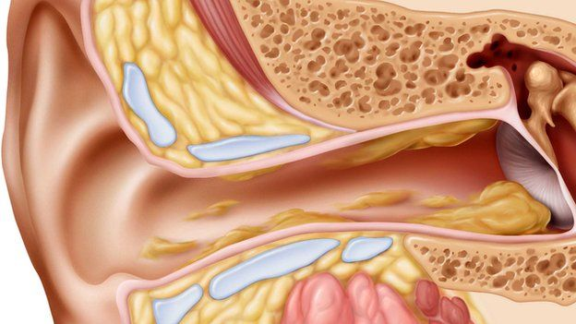Example: ear wax to prevent microorganisms from entering the ear canal

Lipids have more bonds than carbohydrates.

* Breaking bonds releases energy
* Lipids have high potential energy

2:12 Nucleic Acids and Proteins

NUCLEIC ACIDS: complex biological compounds made of chains of nucleotides, serve as instructions for protein synthesis; examples – DNA, RNA

* Functions: Store hereditary information; Energy storing molecule (ATP)
* Monomers-NUCLEOTIDE: made up of a phosphate group, a five-carbon sugar, and a ring-shaped nitrogenous base

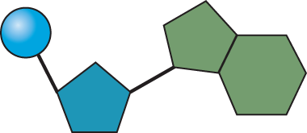

**A phosphate group**

**nitrogen-containing molecule,  
called a base**

**deoxyribose (sugar)**

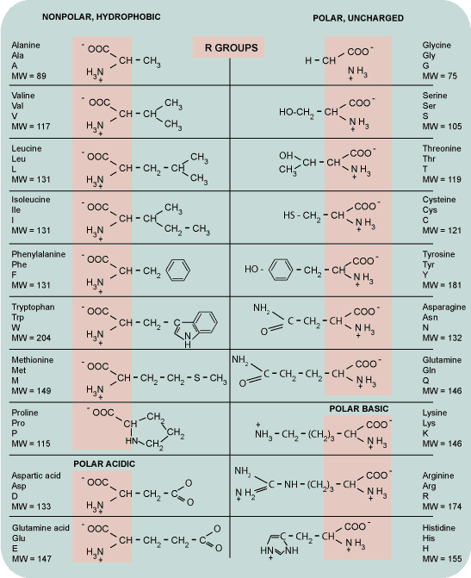

PROTEINS: organic compounds composed mainly of carbon, hydrogen, oxygen, and nitrogen

AMINO ACIDS: “building blocks” of protein

* Monomers of Proteins
* PEPTIDE BOND: when two amino acids form a covalent bond to make proteins by releasing a water molecule
* The 20 amino acids are the “alphabet” from which proteins are formed

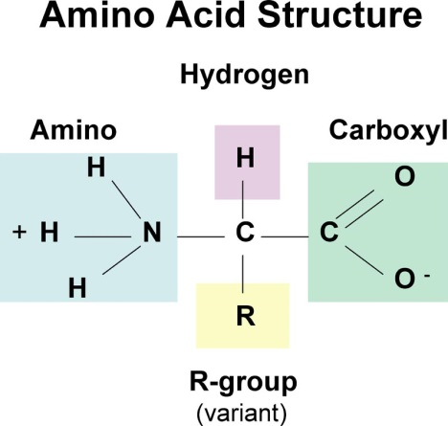The R group is what changes an amino acid and gives proteins very different shapes

* Different shapes allow proteins to carry out many different activities in living things
* Each organism makes its own individual proteins according to the instructions of its DNA
* You ingest plant or animal protein, break it down into amino acids (HYDROLYSIS), and use the amino acids to manufacture your proteins (DEHYDRATION SYNTHESIS).

2:13 Enzymes

CATALYSTS: substance that changes the rate of a chemical reaction without being affected by the reaction

ENZYMES: proteins that act as catalysts in living organisms; example - digestive enzymes

SUBSTRATE: substance(s) that an enzyme causes to react

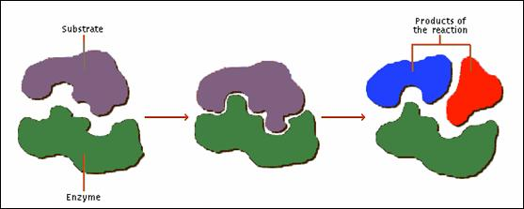ACTIVE SITE: area where enzyme and substrate fit together during reaction

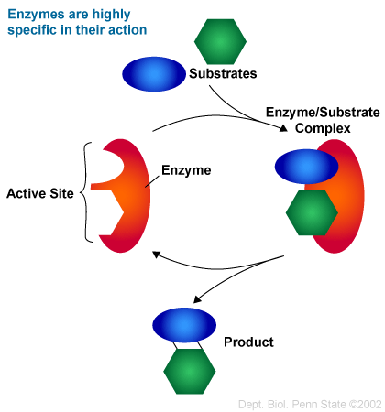How do enzymes work?

1. The enzyme and the substrate fit together at the active site forming the enzyme-substrate complex.
2. Reaction occurs.
3. Enzyme is released and may be re-used.

Denaturing Proteins

1. Change in Temperature (Fever)
2. Change in pH levels
3. Introducing an inhibitor (snake venom)

Enzymes can work faster if you have an activator. Your metabolism can be controlled through enzyme activators.

2:14 Summarize Macromolecules

|  |  |  |  |
| --- | --- | --- | --- |
| ***Macromolecule*** | ***Monomer*** | ***Function*** | ***Example*** |
| **Carbohydrate** | Monosaccharide | * Energy source * Structural materials | * Glucose * Fructose * Starch |
| **Proteins** | Amino Acids | * Structural * Defensive * Catalysts | * Soy beans * Cheese * Pumpkin seed * Enzymes |
| **Lipids** | Glycerol and Fatty Acids | * Store energy * Make-up cell membrane | * Oils * Fatty meats |
| **Nucleic Acids** | Nucleotide | * Genetic info * Energy source | * DNA * RNA * ATP |

-