6:2 Chromosome Number
Every species has a characteristic number of chromosomes which is different from other species.
Example: nematode worm 2 pairs
protozoan 300 pairs
human 23 pairs

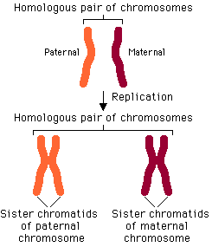
Chromosomes occur in pairs in sexually reproducing organisms. One of the pair comes from the MOM and the other comes from the DAD.

HOMOLOGOUS CHROMOSOMES: two members of a pair of chromosomes that carry genes for the same traits, have the same size and shape, but not identical

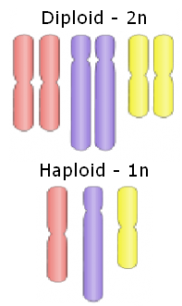
DIPLOID (2N): total chromosome number in a body or somatic cell, having both chromosomes of a homologous pair.
Diploid or 2N number in humans is 46 chromosomes.

HAPLOID (1N): chromosomes number in sex cell (egg or sperm), only one chromosome from each homologous pair.
Haploid or 1N number in human egg or sperm is 23

SEX CHROMOSOMES: chromosomes that determine the sex of an organism, and carry the genes for other characteristics (X or Y), in humans there are 2
- Females have XX
- Males have XY

AUTOSOMES: non-sex chromosomes, in humans there are 44
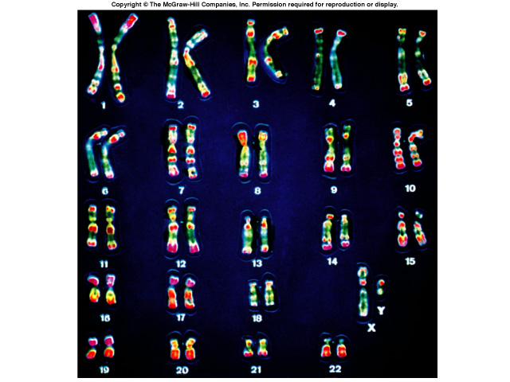

KARYOTYPE: a pictorial display that shows an individual’s chromosomes arranged in homologous pairs and in order of diminishing size

First 22 are autosomes

Last 2 are sex chromosomes

