6:3 Cell Division in Prokaryotes

ASEXUAL REPRODUCTION: production of offspring from one parent
- Example:
  - BINARY FISSION: a form of asexual reproduction in single-celled organisms by which one cell divides into two cells of the same size, division of prokaryotes
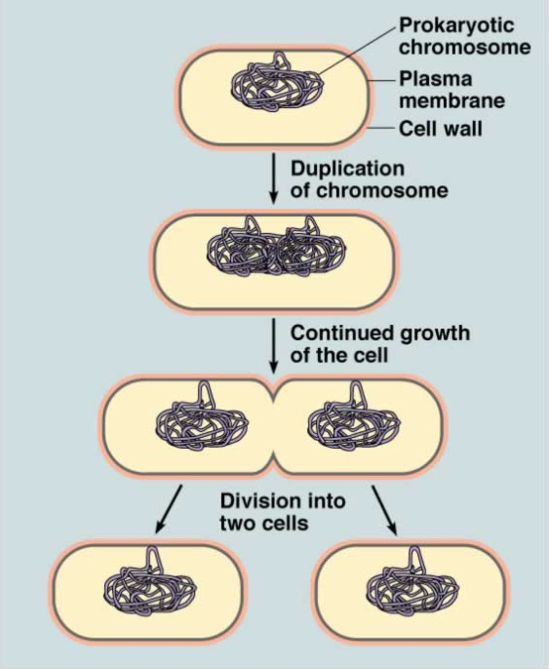
- The DNA is copied, resulting in two identical chromosomes attached to the inside of the cell membrane.
- The cell grows until it reaches approximately twice the cell’s original size.
- The growing cell membrane pushes inward and the cell is constricted at the center.
- A new cell wall forms around the new membrane.

6:4 Cell Division in Eukaryotes

- ASEXUAL REPRODUCTION: production of offspring from one parent
  - Example:
    - MITOSIS: occurs in eukaryotic cells, a process of cell division that forms two new nuclei, each of which has the same number of chromosomes

- SEXUAL REPRODUCTION: reproduction in which sex cells from two parents unite
  - Examples:
    - MEIOSIS: a process in cell division during which the number of chromosomes decreases to half the original number by two divisions of the nucleus, which results in the production of sex cells

CELL CYCLE: sequence of events that occurs during the life of a cell from cell division to cell division.

EVENTS OF THE CELL CYCLE:
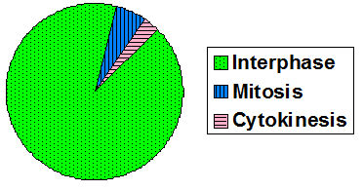
- Interphase
- Mitosis
- Cytokinesis

The Cell Cycle is a continuous process; cells are at some point in the cycle at all times.
