6:5 Interphase

INTERPHASE: the period of cell growth and development that precedes mitosis and follows cytokinesis.

Events of Interphase:
- The cell spends most of its life in interphase.
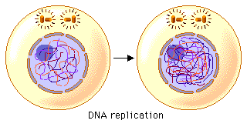
- 3 phases of Interphase:
- G₁ phase:
  - Cells grow bigger
  - DNA is in chromatin form, spread throughout the nucleus

- S phase:
  - Synthesize (make) DNA, cell will contain two exact copies of each chromosome
- G₂ phase:
  - Prepares for cell division
  - Grows bigger
  - Makes organelles needed for cell division
- Some cells enter G₀ phase:
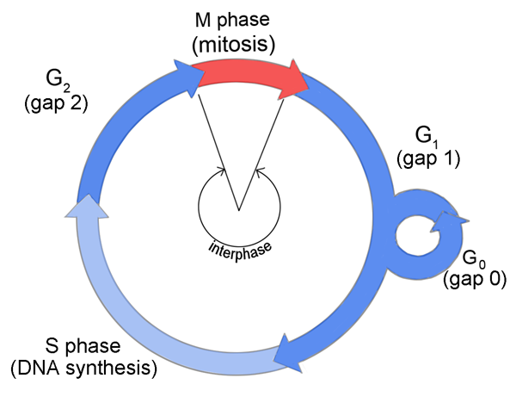
  - Cells do not copy their DNA and do not prepare for cell division
  - Exit the cell cycle after G₁ phase
  - Examples: fully developed cells in the central nervous system, heart muscle cells
