6:6 Mitosis

MITOSIS: the division of the cell nucleus in which the parent cell’s chromosomes divide into two identical sets.

PARENT CELL: original cell that divides into two new cells.

DAUGHTER CELL: two identical cells that result from cell division of the parent cell.

Mitosis must be very orderly and organized to exactly divide the replicated chromosomes into two new cells.
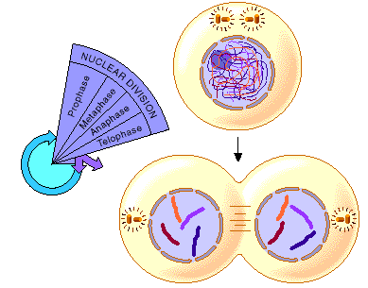

FOUR PHASES OF MITOSIS
1. PROPHASE
- 1st dividing phase
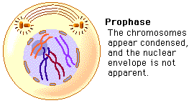
- Centrioles move to opposite sides of cell.
- Chromatin coils into chromosomes.
- Nuclear membrane and nucleolus disappear.
- Spindle fibers form from microtubules and attach to chromosomes

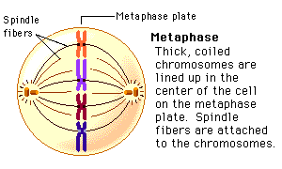
2. METAPHASE
- Spindle fibers attach to paired sister chromatids
- Chromosomes (both sister chromatids) move to the equator (middle of cell).
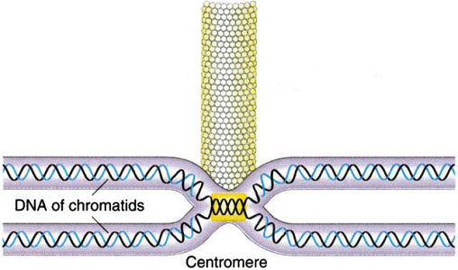

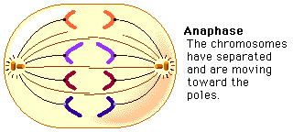
3. ANAPHASE
- Centromeres Split
- Chromatids are now considered to be individual chromosomes
- Spindle fibers shorten and pull the chromosomes AWAY to opposite poles of the cell.

4. TELOPHASE
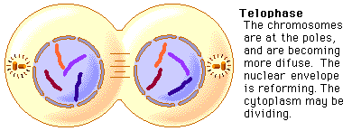
- Centrioles and spindle fibers disappear.
- Chromosomes unwind into chromatin
- Nuclear membrane forms around TWO masses of chromatin.
- Nucleolus re-appears.

MITOTIC PHASE CHROMOSOMES SPINDLE
Prophase | Condense from chromatin | Appears
Metaphase | Line up in the MIDDLE | Attaches to chromosomes
Anaphase | Moves AWAY to poles | Shortens
Telophase | Unwind into chromatin | Disappears
