6:7 Cytokinesis

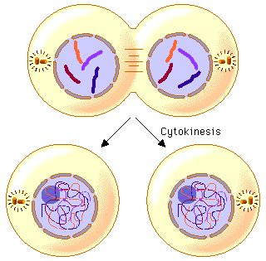
CYTOKINESIS: the division of the parent cell’s cytoplasm into two daughter cells.
Events of Cytokinesis:
- Immediately follows mitosis.
- Cytoplasm from original parent cell splits to form two new cells.
- Each new cell contains one of the nuclei formed by mitosis.
- Other cell structures are evenly distributed into two new, equally sized cells.

DIFFERENCES IN CYTOKINESIS - PLANT versus ANIMAL
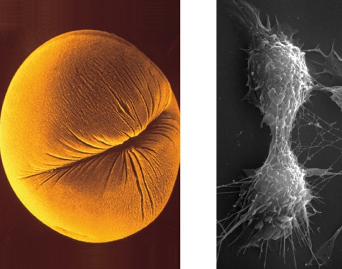
ANIMAL cell membrane pinches in dividing the cell with a cleavage furrow

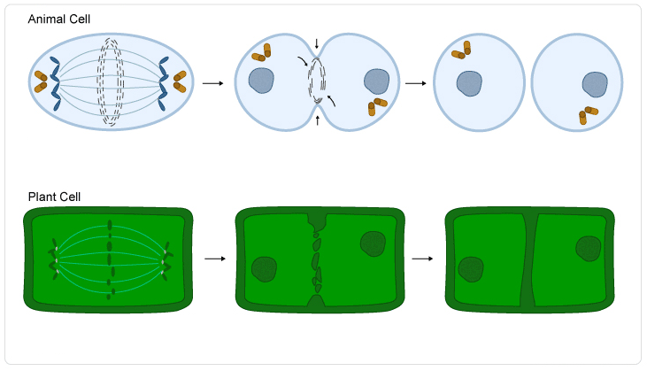
PLANT cell plate (which becomes cell wall) forms in the middle of the cell; cannot pinch because too rigid

Summary of Events in the Cell Cycle
- ____________________________
  - ____________________________
  - ____________________________
  - ____________________________
- ____________________________
  - ____________________________
  - ____________________________
  - ____________________________
  - ____________________________
____________________________

