6:8 Meiosis

- SEXUAL REPRODUCTION: reproduction in which sex cells from two parents unite
  - Examples:
    - MEIOSIS: a process in cell division during which the number of chromosomes decreases to half the original number (haploid) by two divisions of the nucleus, which results in the production of sex cells
Advantages of Sexual Reproduction:
- Allows for variation in population
- Individuals can be different
- Provides foundation for evolution
- Allows species to adapt to changes in their environment

Steps of Meiosis
- Meiosis I
  - Prophase I:
    - DNA coils tightly into chromosomes
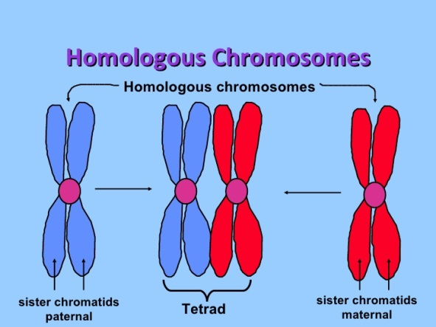
    - SYNAPSIS: pairing of homologous chromosomes during meiosis
    - TETRAD: four chromatids in a pair of homologous chromosomes that come together in synapsis
    - Chromatids twist around one another
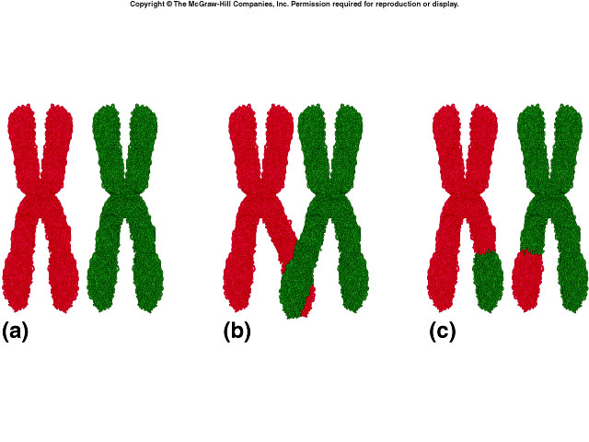
    - CROSSING-OVER: exchange of genetic material between homologous chromosomes that can result in genetic recombination
  - Metaphase I:
    - Tetrads line up randomly along the center of the cell
    - Spindle fibers from one pole attach chromosomes
  - Anaphase I:
    - Each homologous chromosome moves to an opposite pole of the dividing cell.
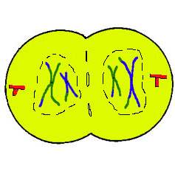
    - INDEPENDENT ASSORTMENT: random separation of homologous chromosomes
  - Telophase I and Cytokinesis I
    - Nuclear membranes reform
    - The cell separates into 2 cells

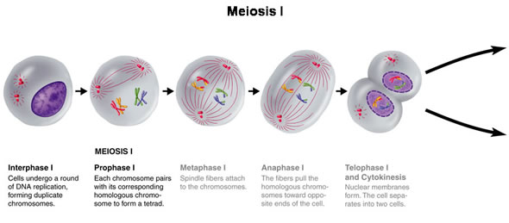
- Meiosis II
  - Prophase II
    - 2 genetically different cells
    - Spindle fibers form
  - Metaphase II
    - Chromosomes move to the MIDDLE of the cell (similar to mitosis)
  - Anaphase II
    - Chromatids separate and move toward opposite poles of the cells
  - Telophase II and Cytokinesis II
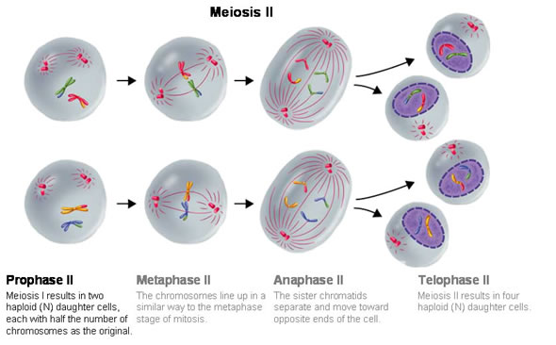
    - Nuclear membrane forms around the chromosomes of the four new cells
    - Cytokinesis occurs, results in four haploid cells (1n)

Meiosis produces haploid (1n) egg cells and haploid (1n) sperm cells that fuse during fertilization to form a diploid (2n) zygote.

Differences between Mitosis and Meiosis:
 | Meiosis | Mitosis
Type of Reproduction | Sexual | Asexual
Genetically | Different | Identical
Crossing Over | Yes | No
Pairing of Homologous Chromosomes | Yes | No
Function | Genetic diversity through sexual reproduction | Cellular reproduction and general growth and repair of the body
# of Divisions | 2 | 1
# of Daughter Cells | 4 Haploid Cells | 2 Diploid Cells
