Name:_________________________ Date: ________________ Hour: ___________
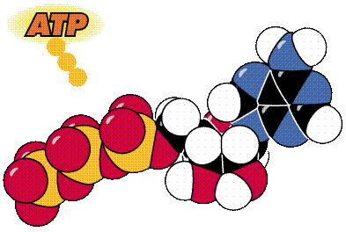
ATP Lab

Question: What is ATP and how is it used by living cells?

Outcome: Students will be able to EXPLAIN the cycle of ATP to ADP in cells.

ATP or adenosine triphosphate is the main energy-carrying or energy-transferring molecule of all living things. In cellular respiration, the energy in the food you eat is released and used to power the cell and its functions. ATP is the molecule that accepts the energy from the food when it is broken down and transfers it to where it is needed in the cell. In photosynthesis, light energy is first captured by chlorophyll and transferred to ATP that then goes to power the process of making glucose. ATP is the energy “currency” of the cell. When a cell needs work to be doe it must spend its ATP.

ATP is made up of three subunits: an adenine molecule, a ribose sugar and 3 phosphate groups. “Adenosine” is the term used for the molecule formed when adenine is bonded to ribose. When two phosphate groups are attached it is called ADP (adenosine diphosphate).

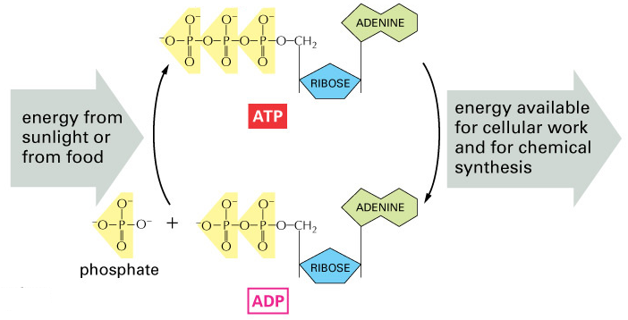
The useable energy in ATP is stored in the last “high-energy” bond holding on the third phosphate group. The energy that is released during the formation of ADP is used to perform cellular work or a specific function. ADP does not have enough energy to perform cellular work so it must be turned back into ATP by adding a phosphate group back on. The energy needed to “reenergize” ATP by adding a phosphate comes from the chemical breakdown of the food we eat (cellular respiration) or from light energy (photosynthesis). Energy is stored in the bonds of glucose during photosynthesis. During cellular respiration, energy is made available (released) from the breakdown of glucose (food) and is used to change ADP to ATP.

It is estimated that humans use almost their body weight in ATP each day to keep their cells functioning. In fact, a cell can use about 2 trillion molecules of ATP per second!! Where does all of the ATP come from? You guessed it; it is recycled over and over again from ADP. Just like rechargeable batteries.

Part A: Chemical Structure of ATP
- What does the prefix tri- in triphosphate mean? ________________________
- Adenosine is a word made up of the combination of two different words. A part of the word comes from ribose (the letters “os”). Where do the letters “aden” and “ine” come from? ____________________________________________________________
- What is needed to form the connections or bonds between the phosphate molecules _______________________________________________________________
- What is therefore needed to form bonds in general? _________________________

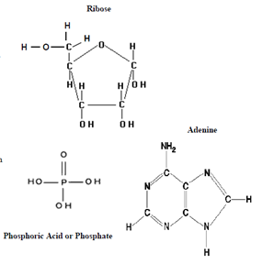
Look at the following diagrams to answer these questions. Count the number of atoms present in each molecule to answer the following questions.

- What is the molecular formula of ribose? C____H____O_____
- What is the molecular formula of adenine?
C____H____N_____
- What atom is present in adenine that was NOT present in ribose? _______________
- What atom is present in ribose that is NOT present in Adenine? ____________________
- What is the molecular formula for phosphoric acid? H____P____O_____

Part B: Constructing the ATP Molecule
Materials: Toothpicks, assorted soft candies
Create a key for each part of the ATP
- Adenine: __________________
- Ribose: ___________________
- Phosphate: ________________

Create a model of ATP using the materials. Draw your model in the box below. Label each piece of candy in your drawing as an Adenine, Ribose, or Phosphate.

Now, remove one phosphate group from the end of your ATP model. Draw your model in the box below. Label each piece of candy in your drawing as an Adenine, Ribose, or Phosphate.

- How many phosphate groups are attached to the ADP? _______________________
- List the four “building blocks” that are needed to form one ADP molecule:
  - ______________________________
  - ______________________________
  - ______________________________
  - ______________________________
- When the phosphate group was removed from ATP to make ADP, what else was released? _________________________________________________________________
- Therefore, what happens when bonds break? _________________________________
- Look at the following equation:

ATP ADP + Phosphate + Energy
  - Everything before the arrow is a reactant. So what is the reactant in the equation? ______________________________________________________________
  - Everything after an arrow is a product. What are the products? ______________________________________________________________

- What do the cells do with the energy that is released during the formation of ADP? (Hint: look at the beginning of the lab) _____________________________________
______________________________________________________________________________________________________________________________________________________________________________________________________
- After the energy in a molecule of ATP is used, the cell is left with a molecule of ADP and a phosphate group (P). What will happen to these molecules? _____________________
____________________________________________________________________________________________________________________________________

- Look at the following equation:
ADP + Phosphate group + Energy ATP
  - What are the reactants? ___________________________________________
  - What are the products? ___________________________________________

- Why does a cell want to convert ADP to ATP? ________________________________
__________________________________________________________________
- What is the advantage to having a vast supply of ATP in the cell? __________________
__________________________________________________________________
- What is required to rejoin the ADP and the P molecules? ________________________
- ATP and ADP function much like batteries that store energy, until the cell needs it. If ADP can be compared to an uncharged battery, to what would ATP be compared? _______________________________
- What type of organism can make their own food? AUTOTROPH or HETEROTROPH
- What type of organism cannot make their own food and must obtain energy from the food they eat? AUTOTROPH or HETEROTROPH

Use each of the terms below just once to complete the passage:
Energy Phosphate Adenine Charged
ATP Chemical Bonds Work Ribose

To do biological _________________________, cells require energy. A quick source of energy that cells use is the molecule _______________________. The ___________________ in this molecule is stored in its __________________________. ATP is composed of a (n) ____________________________ molecule bonded to a(n) ___________________________ sugar. Three ________________________ molecules called __________________ groups are attached to the sugar.

