Department of Health and Human Services
Writing Prompt Details

- Create a professional letterhead that includes your name and address at the top (center)
  - The city, state, and zip code are included on the same line, while the street address has its own line
- ONE SPACE
- Due Date of paper
- ONE SPACE
- Type out the recipient’s address
  - Correct information:
    - Mr. Eric D. Hargan, Secretary
The United States Department of Health and Human Services
200 Independence Avenue, S.W.
Washington, D.C. 20201
  - Left-aligned and single-spaced
  - Recipient’s name should be written on its own line, as the should the recipient’s title, name of the company, and street address
  - The city, state, and zip code are included on the same line
- ONE SPACE
- Dear Secretary Hargan:
- ONE SPACE
- 3 body paragraphs
  - Justify the three paragraphs ()
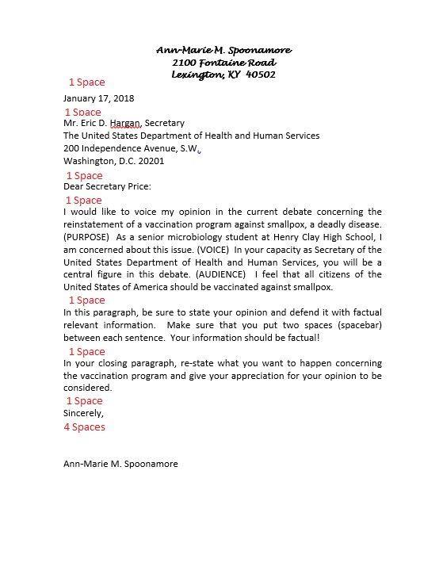
  - 1 space between each paragraph
- ONE SPACE
- Sincerely
- FOUR SPACES
- Type your name

- Margins: Normal
- Font: Times New Roman/Arial
- Font Size: 12 pt.
- Alignment: left-aligned (except letterhead)
- Spacing: single
- Length: 1 pg. ONLY

