Fall Final Review 2016-Biology
Name: __________________________________ Date: _________________ Test #: ______________
Unit 1-Introduction to Science
- Be able to convert between metric units. Starting with Kilo all the way to milli, state the prefixes and base units from largest to smallest.

- Convert 7.0 cm to _________________ mm
- Convert 5.21 Hg to ________________ g
- Convert 6.21 mL to ________________ L
- What are the units of measurements in SI (metric) for length, mass, and liquid volume?
- Biology is the study of ____________________.
- Define and describe the 8 seven characteristics of life.
1. __________________________________________________________________________________
2. __________________________________________________________________________________
3.__________________________________________________________________________________
4.__________________________________________________________________________________
5.__________________________________________________________________________________
6.__________________________________________________________________________________
7.__________________________________________________________________________________
8.__________________________________________________________________________________
- What is a hypothesis? __________________________________________________________________
____________________________________________________________________________________
- What is the purpose of a controlled experiment? _____________________________________________
____________________________________________________________________________________
- What is a theory? ____________________________________________________________________
___________________________________________________________________________________
- Can theories be changed? If so, how? _____________________________________________________
____________________________________________________________________________________
- Be able to identify examples of both independent and dependent variables in a given scenario.
  - What is an independent variable? __________________________________________________
______________________________________________________________________________
  - What is a dependent variable? __________________________________________________
______________________________________________________________________________

Unit 2, Part 1-Chemistry
- What are the three subatomic particles in an atom? Name the charge of each.
  - _____________________________________________________________________
  - _____________________________________________________________________
  - _____________________________________________________________________
- Define element. _____________________________________________________________________
___________________________________________________________________________________
- Define ion. _________________________________________________________________________
___________________________________________________________________________________
- Define isotope. ______________________________________________________________________
___________________________________________________________________________________
- Where are the reactants in a chemical equation located? ______________________________________
- Where are the products in a chemical equation located? ______________________________________
- What is the name of a bond where atoms share electrons? ____________________________________
- What is the name of the bond where atoms transfer electrons? ________________________________
- How is the concentration of a solution determined? _________________________________________
- What is the pH range of an acid? ________________________________________________________
- What is the pH range of a base? _______________________________________________________
- What is a buffer? ____________________________________________________________________
- If you add 10% sulfuric acid to a solution, what type of ions would increase in the solution? _________
- How many electrons can the first energy level hold? ________________________________________
- Use the element information to answer the following questions. Show your math.
  - How many protons are in Nitrogen? _________________
  - How many electrons are in the element Nitrogen? ________________

  - How many neutrons are in the element Fluorine? _________________

  - Draw the correct Bohr Model for Nitrogen.
28. Label the following Macromolecules:
a. 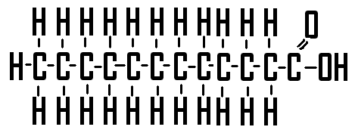 b. 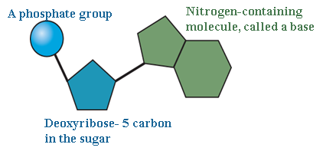 c. 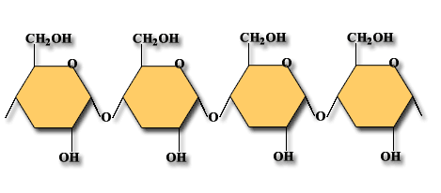
__________________________ ___________________ ________________________
Unit 2, Part 2-Macromolecules
29. What element must all organic compounds have? _______________________________________
30. List the four macromolecules, their monomers (building blocks) and examples of each.
Macromolecule | Elements | Monomer | Examples
1.
2.
3.
4.

31. List the four functional groups from your notes and their formulas.
Functional Group | Structural Formula
 | 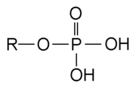

32. What are enzymes and their function? ________________________________________________________
________________________________________________________________________________________________________________
33. If humans did not have enzymes, what would happen to the chemical reactions in our bodies? ________________________________________________________________________________________________________________

Unit 3-Cells
- What are 3 differences between prokaryotic and eukaryotic cells? ______________________________
___________________________________________________________________________________
- What is an organelle? _________________________________________________________________
- What are the 3parts of the cell theory? ____________________________________________________
___________________________________________________________________________________
- Write out the correct order of organization of structures in living things, from simple to most complex.
___________________________________________________________________________________
- Write out the function for the following organelles and know what type of cell it is found in. In addition, be able to identify it in a cell.
  - Nucleus: _______________________________________________________________________________
  - Nuclear Membrane: ______________________________________________________________________
  - Plasma Membrane: _______________________________________________________________________
  - Mitochondria: ___________________________________________________________________________
_______________________________________________________________________________________
  - Endoplasmic Reticulum: ___________________________________________________________________
_______________________________________________________________________________________
  - Golgi Apparatus: _________________________________________________________________________
_______________________________________________________________________________________
  - Chloroplasts: ____________________________________________________________________________
_______________________________________________________________________________________
  - Vacuole: _______________________________________________________________________________
i. Cilia: __________________________________________________________________________________
Include whether it’s active or passive, if it uses a protein, if it goes high to low or low to high and any other info
- What is diffusion? ___________________________________________________________________
__________________________________________________________________________________
- What is facilitated diffusion? ___________________________________________________________
___________________________________________________________________________________
- Define osmosis. _____________________________________________________________________
___________________________________________________________________________________
- Compare an isotonic solution, hypotonic solution and hyper tonic solution. ______________________ ___________________________________________________________________________________
___________________________________________________________________________________
- Compare endocytosis and exocytosis. Be able to recognize pictures of these processes. _____________
___________________________________________________________________________________
___________________________________________________________________________________
- What is the process whereby animal cells engulf, digest, and destroy invading bacteria? ____________

Unit 4-Photosynthesis and Cellular Respiration
- What is photosynthesis? _______________________________________________________________
- What is the equation for photosynthesis? __________________________________________________
- What is the role of chlorophyll in photosynthesis? __________________________________________
- What are the inputs or reactants of the light-dependent reactions? ______________________________
- What are the 3 products of the light dependent reaction?______________________________________
- Which of these provide energy for the Calvin Cycle? _______________________________________
- What are the products of the Calvin Cycle? _______________
- Where in the chloroplast does each of the following reactions take place?
  - Light-dependent: ____________________________________________________
  - Calvin Cycle (light-independent): ____________________________________________

- What is the equation for cellular respiration? ______________________________________________
- What are the three steps of aerobic cellular respiration in the correct order? ___________________________________________________________________________________
- Cell respiration is an aerobic process. What does that mean it requires? _________________________
- Which process within cellular respiration takes place in the cytoplasm? _________________________
- What organelle does the rest of cell respiration occur in? ____________________________________
- Explain the difference between ATP and ADP._____________________________________________
___________________________________________________________________________________
- How is energy released from ATP? ______________________________________________________
- What is fermentation? ________________________________________________________________
- What are the two types of fermentation? __________________________________________________

Unit 5-DNA
- What are the monomers for DNA? _______________________________________________________
- What are the three parts of a nucleotide? __________________________________________________
- What part of DNA is it named after? _____________________________________________________
- What two scientists are given the credit for establishing the structure of DNA? ___________________
- What does Chargaff’s rule state? ________________________________________________________
___________________________________________________________________________________
- Be able to pair complementary strands. Example: What strand would match TCGAAC in DNA?
_________
- What enzyme attaches spare nucleotides to the DNA template? ______________________________
- What was the key idea from Griffith’s experiment? _________________________________________
___________________________________________________________________________________
64. What is the function of mRNA? _________________________________________________________
65. What is the function of tRNA? __________________________________________________________
66. Explain 3 ways RNA is different from DNA. _______________________________________________
___________________________________________________________________________________
___________________________________________________________________________________
67. 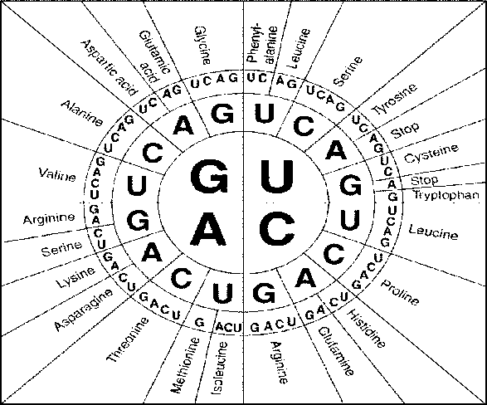
Answer the questions using the codon chart.
DNA: _____ _____ _____ ______
mRNA: A U G C C A U G G C A U
tRNA: _____ _____ _____ ______
Amino acid:
_________ - __________ - _________ - ________

68. What are the 3 types of RNA? ___________________________________________________________
67. What happens during transcription and where in the cell does it occur? ___________________________
___________________________________________________________________________________
68. What happens during translation and where in the cell does it occur? ____________________________
___________________________________________________________________________________
69. What is a codon? _____________________________________________________________________
70. What is an anticodon? _________________________________________________________________

