Fall Final Review 2016-Biology
KEY KEY KEY KEY KEY KEY KEY KEY
Unit 1-Introduction to Science
- Be able to convert between metric units. Starting with Kilo all the way to milli, state the prefixes and base units from largest to smallest.

- Convert 7.0 cm to ____70__ mm
- Convert 5.21 Hg to ___521___ g
- Convert 6.21 mL to __.00621___ L
- What are the units of measurements in SI (metric) for length, mass, and liquid volume?
Length- meters, Mass- grams, Liquid Volume- liters
- Biology is the study of ____life_______.
- Define and describe the 8 seven characteristics of life.
1. They are organized and made up of units called CELLS
2. They Reproduce
3. Living things have a universal genetic code (DNA)
4. They Grow (get bigger) and develop (mature)
5. They obtain and use materials and energy (metabolism)
6. They respond to their environment or a stimulus
7. They maintain a stable and balanced internal environment (homeostasis)
8. They change over time (evolution)

- What is a hypothesis? Proposing an explanation for the way part of the natural world functions
It must be testable- evidence can be collected that either does or doesn’t support it
It can never be proven beyond doubt
It often must be changed, revised or discarded after testing

- What is the purpose of a controlled experiment? CONTROLLED EXPERIMENT: test done several times while keeping all variables the same except the one being tested. This allows the experimenter to isolate and test a single variable in the experiment.
- What is a theory? A broad and comprehensive statement of what is thought to be true. Theories are supported by considerable amounts evidence and can be changed or revised as new discoveries are made.
- Can theories be changed? If so, how? Theories can be changed if new evidence is discovered. They can be revised or discarded as needed.

- Be able to identify examples of both independent and dependent variables in a given scenario.
  - What is an independent variable? “THE CAUSE” the factor being tested in a controlled experiment, the factor presumed to be the cause of the effect according to the hypothesis, Goes on the X axis
  - What is a dependent variable? “THE EFFECT” the difference in results between experimental group and control group, it’s the change that happens from the use of the independent variable. Goes on the Y axis. This is usually what you are measuring in the experiment.

Unit 2, Part 1-Chemistry
- What are the three subatomic particles in an atom? Name the charge of each.
  - Proton= positive charge
  - Electron= negative charge
  - Neutron= neutral charge
- Define element. A substance that cannot be broken down to simpler substances by ordinary means. Made of only 1 type of atom. Example: The element Carbon is made of only carbon atoms.
- Define ion. atoms which carry a positive or negative electrical charge due to loss or gain of electrons
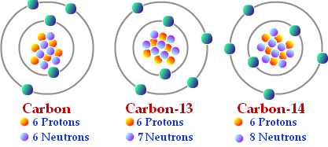
- Define isotope. atoms of the same element (same atomic #) with different numbers of neutrons (different atomic mass)See picture.

- Where are the reactants in a chemical equation located? On the left side of a chemical equation.
- Where are the products in a chemical equation located? On the right side of a chemical equation.
See picture for #17&18:
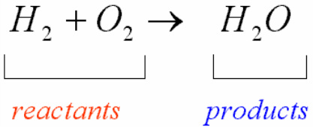
- What is the name of a bond where atoms share electrons? Covalent bond
- What is the name of a bond where atoms transfer electrons? Ionic bond
- How is the concentration of a solution determined? The amount of solute dissolved in a fixed amount of the solution
- What is the pH range of an acid? 0-up to 7
- What is the pH range of a base? Above 7 up to 14. 7 is neutral
- What is a buffer? chemical substances that neutralize small amounts of acids or bases (bringing the pH closer to 7)
- If you add 10% sulfuric acid to a solution, what type of ions would increase in the solution? Hydrogen or Hydronium ions would increase in an acid. (Hydroxide ions increase in a base.)
- How many electrons can the first energy level hold?____ 2______
- Use the element information to answer the following questions. Show your math.
  - How many protons are in Nitrogen? _7____
The atomic number is the number of protons
  - How many electrons are in the element Nitrogen? ____7___
The number of electrons must equal the number of protons
  - How many neutrons are in the element Fluorine? ____7____
The atomic mass is 14. To calculate the number of neutrons you must
subtract the atomic number (7) from the atomic mass (14) to find the number of neutrons. 14-7=7

  - Draw the correct Bohr Model for Nitrogen.
You must plot the correct number of electrons on the orbital. Nitrogen has 7 electrons= only 2 can fit in the inner most orbital. The next orbital can hold up to 8 but only needs to hold 5 for nitrogen.
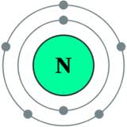
28. Label the following Macromolecules:
a. 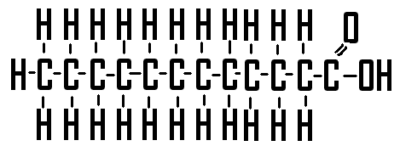 b. 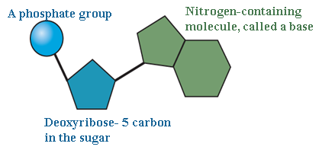 c. 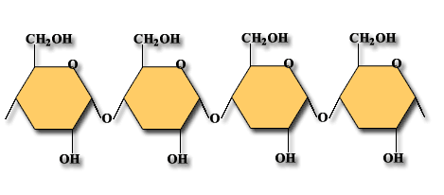
Lipid Nucleic Acid Carbohydrate
Unit 2, Part 2-Macromolecules
- What is the element that all organic compound must have? One that contains Carbon

Macromolecule | Elements | Monomer | Example
Carbohydrate | CHO | Monosaccharide | - Glucose  - Fructose  - Starch
Lipids | CHO | Glycerol and Fatty Acids, triglycerides | - Oils  - Fatty meats  - Hormones
Proteins | CHON | Amino Acids | - Soy beans  - Cheese  - Pumpkin seed  - Enzymes
Nucleic Acids | CHONP | Nucleotide | - DNA  - RNA  - ATP

- List the four functional groups from your notes and their formulas.
Common Functional Groups:
Functional Group | Structural Formula
Hydroxyl
Carboxyl
Amino
Phosphate | 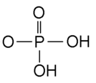

- What are enzymes and their function? A protein that act as catalysts in living organisms; They reduce the activation energy of a reaction causing them to occur quicker.
- If humans did not have enzymes, what would happen to the chemical reactions in our bodies?
The reactions would occur too slowly to support life
Unit 3-Cells
- What are the differences between prokaryotic and eukaryotic cells?
PROKARYOTIC CELL: do not have a nucleus, nuclear membrane or membrane bound organelles. Eukaryotic cells must have a nucleus, nuclear membrane and membrane bound organelles.
35. What is an organelle? “little organs”, functional parts of the cell, separated from the cytoplasm by membranes
- What does the cell theory state?
CELL THEORY:
-all living things are made of cells
-cells are the basic unit of structure and function in an organism
-cells come from the reproduction of existing cells
- Write out the correct order of organization of structures in living things, from simple to most complex.
CELLS TISSUES ORGANS ORGAN SYSTEMS ORGANISM

- Write out the function for the following organelles and know what type of cell it is found in. In addition, be able to identify it in a cell.
  - NUCLEUS: central portion of the cell that contains DNA and controls cells functions
  - NUCLEAR MEMBRANE: boundary between cytoplasm and nucleus; double membrane with pores
  - PLASMA MEMBRANE or CELL MEMBRANE: acts as a barrier between the inside and the outside of a cell. The cell membrane only allows certain thing to pass through.
  - MITOCHONDRIA: site of cellular respiration; changes glucose (cell food) to ATP (cell fuel) for energy to run the cell. Surrounded by a double membrane and has its own DNA

  - Endoplasmic Reticulum: system of double membranes, transports materials through the cell. There are 2 types: a. Rough Endoplasmic Reticulum-has ribosomes on its surface to make membrane proteins and proteins for export out of the cell
b. Smooth Endoplasmic Reticulum-makes cell products that are used inside the cell. No ribosomes on the surface.
  - Golgi Apparatus: modifies and packages proteins for export from the cell.
  - Chloroplasts: organelles that contain chlorophyll (green pigment), site of photosynthesis (making food from energy of the sun).
  - Vacuole: fluid filled storages sites
  - Cilia: small hair like organelles that are found on the cell surface
Include whether it’s active or passive, if it uses a protein, if it goes high to low or low to high and any other info
- What is diffusion? A type of passive transport that moves particles from areas of high concentration to areas of low concentration. Does not use a protein and can pass through a semi-permeable membrane.
- What is facilitated diffusion? the transport of substances through a cell membrane along a concentration gradient with the aid of carrier proteins, passive transport
- Define osmosis. the diffusion of water molecules from areas of high water concentration to areas of low water concentration, through the cell membrane without help from a protein and passive transport
- Compare an isotonic solution, hypotonic solution and hypertonic solution. A condition where the solution outside the cell contains the SAME concentration of solutes and water as inside the cell is Isotonic. Under ISOTONIC conditions the cell will neither gain nor lose water. Animal cells survive best in these conditions.,
- Compare endocytosis and exocytosis. Be able to recognize a picture of this process.
Both are active transport. Exocytosis is the process by which a substance is released from the cell through a vesicle that transports the substance to the cell surface and then fuses with the membrane to let the substance out. Endocytosis is the reverse. It is process by which a substance enters a cell and a vesicle is formed. Phagocytosis and Pinocytosis are examples of endocytosis.
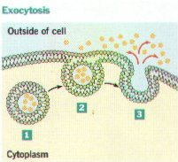 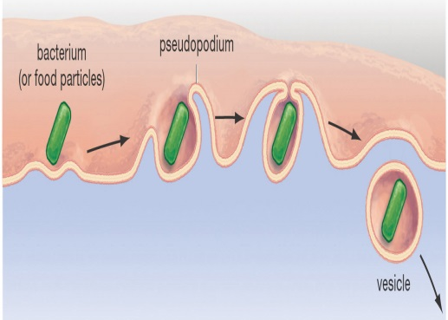 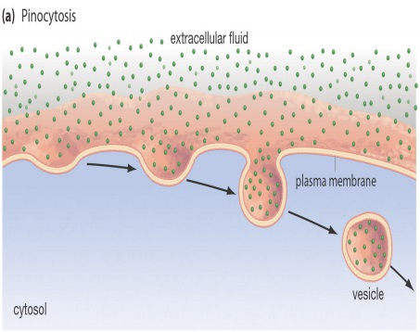
- What is the process where animal cells engulf, digest, and destroy invading bacteria? Phagocytosis which is an example of endocytosis. Endocytosis is an example of active transport and cells taking in large molecules. See in the middle picture above.

Unit 4-Photosynthesis and Cellular Respiration
- What is photosynthesis? series of chemical reactions during which PLANTS change light energy from the sun into chemical energy stored in the chemical bonds of GLUCOSE molecules
- What is the equation for photosynthesis? light energy+ 6 CO₂ + 6 H₂O C₆H₁₂O₆ + 6 O₂
- What is the role of chlorophyll in photosynthesis? to absorb sunlight
- What are the inputs in the light-dependent reactions? Sunlight, CO₂ and H₂O
- What are the 3 products of the light dependent reaction? Oxygen (6 O₂), ATP and NADPH
- Which of these provide energy for the Calvin Cycle? ATP and NADPH
- What are the products of the Calvin Cycle? C₆H₁₂O_{6,} Glucose (sugar)
- Where does each of the following reactions take place?
a. Light-dependent: in the thylakoid membrane
b. Calvin Cycle (light-independent): in the stroma
- What is the equation for cellular respiration?
C₆H₁₂O₆ + 6 O₂ 6 CO₂ + 6 H₂O + 38 ATP (energy)

- What are the three steps of aerobic cellular respiration and in the correct order?
Glycolysis Krebs Cycle Electron Transport Chain
- Cell respiration is an aerobic process. What does that mean it requires? Oxygen
- Which process within cellular respiration takes place in the cytoplasm? Glycolysis
- What organelle does the rest of cellular respiration occur in? Mitochondria
- What is the difference between ATP and ADP? ATP has 3 phosphates connected by 2 high energy bonds. ADP has 2 phosphates connected by only 1 high energy bond. Therefor ADP has one less phosphate than ATP.
- How is energy released from ATP? The last phosphate group is removed and the bond is broken releasing the energy stored in the bond.
- What is fermentation? (anaerobic respiration) the breakdown of glucose to release energy carried out in the absence of oxygen.
- What are the two types of fermentation? Lactic acid fermentation and Alcoholic fermentation

Unit 5-DNA
- What are the monomers for DNA? Nuceleotides
- What are the three parts of a nucleotide? a sugar (deoxyribose), a phosphate group and a nitrogen base
- What part of DNA is it named after? the sugar (deoxyribose)
- What two scientists are given the credit for establishing the structure of DNA? Watson and Crick
- What does Chargaff’s rule state? that Adenine pairs with Thymine and Cytosine pairs with Guanine
- Be able to pair complementary strands. Example: What strand would match TCGAAC?
AGCTTG
- What enzyme attaches spare nucleotides to DNA template bases? DNA Polymerase
- What was the key idea from Griffith’s experiment? Transformation
-Griffith conducted one of the first experiment’s to suggest that bacteria are capable of transferring genetic information through a process known as transformation
- What is the function of mRNA? To copy DNA’s code and carry the genetic information to the ribosomes to perform protein synthesis. Has a CODON for each amino acid
- What is the function of tRNA? To transfer amino acids to the ribosomes where proteins are synthesized. There is an attachment site at one end for an amino acid, the opposite end has a three nucleotide base called an ANTICODON: three nucleotides on the RNA that are complementary to the sequence of a codon in mRNA
72. Explain 3 ways RNA is different from DNA. 1.Ribose is the sugar in RNA, deoxyribose is the sugar in DNA. 2.RNA contains uracil where DNA contains thymine. In RNA uracil bonds to adenine. 3.RNA is a single strand of nucleotides, DNA is a double strand of nucleotides.
73.
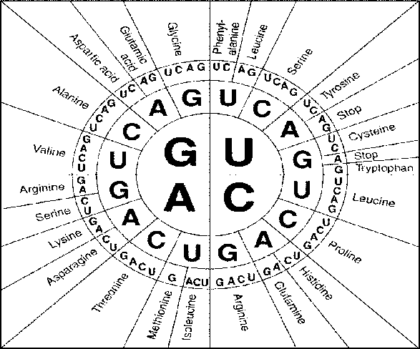
Answer the questions using the codon chart.
DNA: T A C G G T A C C G T A
mRNA: A U G C C A U G G C A U
tRNA: U A C G G U A C C G U A
Amino Acid: Met Pro Thr Val
Amino acid:
_________ - __________ - _________ - ________

74. What are the 3 types of RNA? mRNA, tRNA, rRNA
75. What happens during transcription and where in the cell does it occur? DNA is made into a strand of mRNA in the nucleus of the cell.
76. What happens during translation and where in the cell does it occur? The ribosome reads the mRNA strand and the amino acids are assembled in the correct sequence to make a protein
77. What is a codon? group of 3 bases on a mRNA strand that act as a code word for a specific amino acid
78. What is an anticodon? three nucleotides on the RNA that are complementary to the sequence of a codon in mRNA

