Introduction to Microbiology

Microorganisms are the dominant life forms on earth, are found in almost every conceivable environment, and are essential to sustaining life on this planet. There are five basic groups of microorganisms:

- Bacteria are typically unicellular, microscopic, prokaryotic organisms that reproduce by binary fission.
- Fungi (yeasts and molds) are typically unicellular, microscopic, eukaryotic fungi that reproduce asexually by budding. Molds are typically filamentous, eukaryotic fungi that reproduce by producing asexual reproductive spores.
- Viruses are typically submicroscopic, acellular infectious particles that can only replicate inside a living host cell. The vast majority of viruses possess either DNA or RNA, but not both.
- Protozoa are typically unicellular, microscopic, eukaryotic organisms that lack a cell wall.
- Algae are typically eukaryotic microorganisms that carry out photosynthesis.
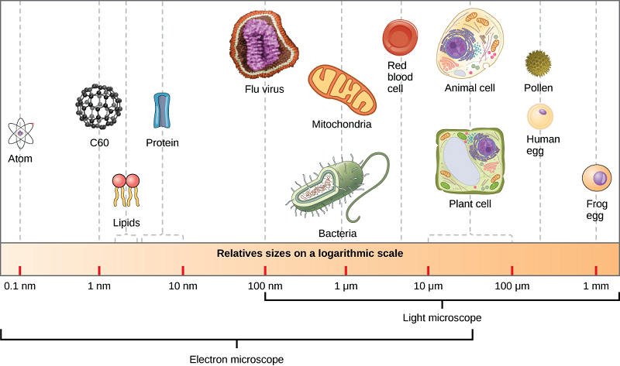

Figure 1.1.1: The size of a virus is very small relative to the size of cells and organelles.

In this course we will be looking at various fundamental concepts of microbiology, with particular emphasis on their relationships to human health. The overall goal is to better understand the total picture of infectious diseases in terms of host-infectious agent interaction. We will look at various groups of microbes and learn what they might do to establish infection and harm the body, we will look at the body to see the ways in which it defense itself against these microbes, and we will learn what can be done to help the body in its defense efforts.

The BIG Picture of Infectious Diseases

One of the most important things in microbiology is learning the “Big Picture of Infectious Diseases,” which is the biological basis of host parasite interaction. There are four interlocking parts to this big picture:
- The microbe’s side of the story-why some microbes have more potential to be harmful: The overwhelming majority of microbes are harmless to humans and, in fact, many are beneficial, being key players in the recycling of nutrients in nature. We will look at the major groups of microbes, learn what they are composed of chemically and structurally, and see how they carry out their metabolism and reproduce. We will learn of a variety of factors some microbes may possess that play a role in increasing their ability to cause disease. Also we will learn how, through mutation, genetic recombination, and natural selection, microbes may adapt to resist our control attempts. (Units 1, 2)
- The body’s side of the story-ways in which the body is able to defend itself naturally against infectious disease agents: Here will learn about the phenomenal defenses the body has available to defend itself against infectious disease agents, as well as altered body cells such as cancer cells and infected cells. The body is able to do this through the innate immune system and the adaptive immune system. Innate immune defenses are those you are born with and include anatomical barriers, mechanical removal, cytokines, pattern-recognition receptors, phagocytosis, inflammation, the complement pathways, and fever. The adaptive immune defenses are those you develop throughout your life and include antibody production and cell-mediated immunity. (Units 3, 4, 5)
- Ways in which we can artificially help the body defend itself by removing the microbes or enhancing body defenses: We will learn how we can artificially help ourselves to avoid or reduce the risk of infection. Also we will learn ways in which we are able to artificially remove microbes from the body and its environment using agents such as antiseptics, disinfectants, physical agents such as heat and cold, antimicrobial chemotherapeutic chemicals, and antibiotics. Finally we will learn ways we are currently able to - or potentially in the future will be able to - improve or restore the body's immune responses through such techniques as immunization, adoptive immunotherapy, or immune modulation. (Units 4, 5, 6)
- Relationship between the Human Microbiome and Human health: The complex mutually beneficial symbiotic relationship between humans and their natural microbes is critical to good health. It is now recognized that the millions of genes associated with the normal flora or microbiota of the human body -especially in the intestinal tract - aid in the digestion of many foods, the regulation of multiple host metabolic pathways, and the regulation the body's immune defenses. (Units 4, 5, 6)

Benefits of Microbial Activity

Most people tend to think of microorganisms as harmful because of their roles in causing infectious diseases in humans and other animals, and agricultural loss as a result of infectious diseases of plants and the spoilage of food. The fact is, however, the vast majority of microorganisms are not harmful but rather beneficial. Without them there would be no life on earth. Therefore, we will start this course by looking at a few of the many benefits from microbial activity on this planet.
- Food production: Many food products employ microorganisms in their production. These include the microbial fermentation processes used to produce yogurt, buttermilk, cheeses, alcoholic beverages, leavened breads, sauerkraut, pickles, and kimchi.
- Energy production and cleaning up the environment: Methane, or natural gas, is a product of methanogenic microorganisms. Many aquatic microbes capture light energy and store it in molecules used as food then used by other organisms. Animal wastes, domestic refuse, biomass, and grain can be converted to biofuels such as ethanol and methane by microorganisms. In addition, through a process called bioremediation, some pollutants such pesticides, solvents, and oil spills can be cleaned up with the aid of microbes.
- Sustaining agriculture: Through their roles in recycling nitrogen, carbon, and sulfur, microorganism are able to convert these essential elements into forms that can be used by plants in their growth. They are also essential in enabling ruminant animals such as cows and sheep to digest cellulose from the grasses they eat.
- Production of useful natural gene products or products from bioengineering. Examples include specific enzymes, antibiotics, vaccines, and medications such as human insulin, interferons, and growth hormones.
- The human microbiota and microbiome: Where we be without microorganisms? While the typical human body contains an estimated 37 trillion human cells, it also contains over 100 trillion bacteria and other microbes. The human body has 3 times as many bacterial cells as it does human cells! It is estimated the mass of the human microbiota is 2.5 pounds.
Microbiology and Heredity
The complex mutually beneficial symbiotic relationship between humans and their natural microbes is critical to good health. It is now recognized that the millions of genes associated with the microbiota of the human body -especially in the intestinal tract - aid in the digestion of many foods, the regulation of multiple host metabolic pathways, and the regulation the body's immune defenses. These collective microbes and their genes are referred to as the human microbiome. There are currently an estimated 5,000,000 - 10,000,000 genes from over 1000 species that constitute the human microbiome compared to the approximately 20,000 - 23,000 genes that make up the human genome. There are approximately 300 non-human genes in the human body for every human gene.
- Regulation of Host Metabolism
The mutually beneficial interaction between the human host and its resident microbiota is essential to human health. Microbial genes produce metabolites essential to the host while human genes contribute to development of the microbiota. The microbiome aids in the following:
  - The digestion of many foods, especially plant polysaccharides that would normally be indigestible by humans.
  - The regulation of many host metabolic pathways. The metabolism of many substrates in the human body is carried out by a combination of genes from both the microbiome and the human genome. Within the intestinal tract there is constant chemical communication not only between microbial species but also between microbial cells and human cells. Multiple factors, including diet, antibiotic use, disease, life style, and a person's environment can alter the composition of the microbiota within the gastrointestinal tract and, as a result, influence host biochemistry and the body's susceptibility to disease.
  - Metabolic disorders such as diabetes, nonalcoholic fatty liver disease, hypertension, obesity, gastric ulcers, colon cancer, and possibly some mood and behavior changes through hormone signaling have been linked to alterations in the microbiota.
- Regulation of Immunity
There is ever growing evidence that commensal bacteria of the gastrointestinal tract, as well as parasitic gastrointestinal helminths, may have coevolved with the human body over the past 200,000 year in such a way that genes from the human microbiota may play a significant role in regulating the human immune responses by providing a series of checks and balances that prevent the immune system from being too aggressive and causing an autoimmune attack upon the body's own cells, while still remaining aggressive enough to recognize and remove harmful pathogens. The microbiota affects the development of the immune system while the immune system influences the composition of the microbiota.
As exposure to and colonization with these once common human organisms has drastically changed over time as a result of less exposure to mud, animal and human feces, and helminth ova, coupled with ever increasing antibiotic use that destroys normal flora, improved sanitation, changes in the human diet, increased rate of cesarean sections, decreased rate of breast feeding, and improved methods of processing and preserving of food, the rates of allergies, allergic asthma, and autoimmune diseases (inflammatory bowel disease, Crone's disease, irritable bowel syndrome, type-1 and type-2 diabetes, and multiple sclerosis for example) have dramatically increased in developed countries while remaining relatively low in undeveloped and more agrarian parts of the world.

Outline of Topics in Microbiology
Unit 1-Introduction to Microorganisms
Unit 2-Laboratory Equipment and Procedures
Unit 3-Bacteria Morphology
Unit 4-Infection and Bacterial Invasiveness
Unit 5-Introduction to Pathogens
Unit 6-Controlling Microbes and Antimicrobial Agents
Unit 7-Viral Structure and Classification

Follow-Up Questions
  - Define microbiota and microbiome. (If necessary, you may use an outside source.) ________________________________________________________________________________________________________________________________________________________________________________________________________________________________________________________________________________________________________________________
  - Briefly describe two different beneficial things the human microbiome does for the normal function of our body. ____________________________________________________________
______________________________________________________________________________
  - State three diseases associated with a change in our “normal” microbiota. __________________
____________________________________________________________________________________________________________________________________________________________
  - What are the five basic groups of microbes? __________________________________________
______________________________________________________________________________
  - What is one fact you learned in this reading of an Introduction to Microbiology? ____________________________________________________________________________________________________________________________________________________________
  - Name two different topics you would like to learn over the course of the semester. ____________________________________________________________________________________________________________________________________________________________
  - Do you have any fears of the microbial world? Explain. ______________________________________________________________________________
______________________________________________________________________________
  - Do you believe in the use of vaccines? (circle one) YES MAYBE UNSURE NO

