Name: ______________
Mitosis and Meiosis EOC Review

The Cell Cycle
Cell division is just one of several stages that a cell goes through during its lifetime. The cell cycle is a repeating series of events, including growth, DNA synthesis, and cell division. The cell cycle in prokaryotes is quite simple: the cell grows, its DNA replicates, and the cell divides. In eukaryotes, the cell cycle is more complicated.
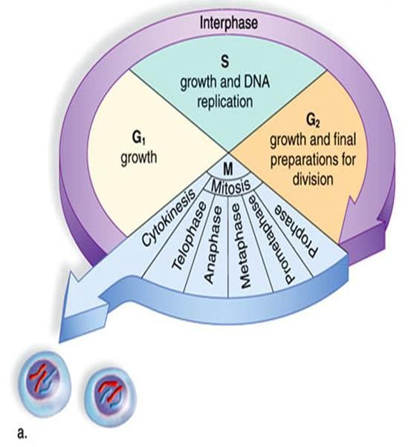

Eukaryotic Cell Cycle
The diagram in the figure below represents the cell cycle of a eukaryotic cell. As you can see, the eukaryotic cell cycle has several phases. The mitosis phase (M) actually includes both mitosis and cytokinesis. This is when the nucleus and then the cytoplasm divide. The other three phases (G1, S, and G2) are generally grouped together as interphase. During interphase, the cell grows, performs routine life processes, and prepares to divide. These phases are discussed below.

This diagram represents the cell cycle in eukaryotes. The G1, S, and G2 phases make up interphase (I). The M phase includes mitosis and cytokinesis. After the M phase, two cells result.

Interphase
Interphase of the eukaryotic cell cycle can be subdivided into the following three phases, which are represented in the figure above:
- Growth Phase 1 (G1): During this phase, the cell grows rapidly, while performing routine metabolic processes. It also makes proteins needed for DNA replication and copies some of its organelles in preparation for cell division. A cell typically spends most of its life in this phase.
- Synthesis Phase (S): During this phase, the cell’s DNA is copied in the process of DNA replication.
- Growth Phase 2 (G2): During this phase, the cell makes final preparations to divide. For example, it takes additional proteins and organelles.

Questions
- What is the cell cycle?
- What are the phases of the eukaryotic cell cycle?
- In which phase does a cell spend most of its life? What happens during this phase?
- What is the S phase? What happens during this phase?
Write true if the statement is true or false if the statement is false.
- _____Cell division is basically the same in prokaryotic and eukaryotic cells.
- _____Cytokinesis is the division of the cytoplasm.
- _____Mitosis is the process in which the nucleus of the cell divides.
- _____A cell spends most of its life in growth phase 1 of the cell cycle.
- _____The correct order of phases of the cell cycle is G1SG2M.
- _____Interphase consists of mitosis and cytokinesis.

Mitosis
Mitosis is a continuous process that is divided into four phases: prophase, metaphase, anaphase, and telophase. Prophase is the first phase of mitosis. Prophase begins with the shortening and tight coiling of DNA into rod-shaped chromosomes that can be seen with a light microscope. During the S phase, each chromosome is copied. The two copies of each chromosome—called chromatids—stay connected to one another by the centromere. At this time, the nucleolus and the nuclear membrane break down and disappear. Two pairs of dark spots called centrosomes appear next to the disappearing nucleus. The centrosomes move toward opposite poles of the cell, and spindle fibers radiate from the centrosomes in preparation for mitosis.

Metaphase is the second phase of mitosis. During metaphase, kinetochore fibers move the chromosomes to the center of the dividing cell.

During anaphase, the chromatids of each chromosome separate at the centromere and slowly move toward opposite poles of the dividing cell. After the chromatids separate, they are considered to be individual chromosomes.

Telophase is the fourth phase of mitosis. After the chromosomes reach opposite ends of the cell, the spindle fibers disassemble and the chromosomes return to a less tightly coiled chromatin state. A nuclear envelope forms around each set of chromosomes, and a nucleolus forms in each of the newly forming cells.

Cytokinesis immediately follows Mitosis. In Cytokinesis, the cytoplasm from the original parent cell splits to form two new cells. Each new cell will contain one of the nuclei formed by mitosis.

Match each statement with the phase of mitosis it describes. Write the letter corresponding to the correct phase in the space provided.

SKILL: Sequencing Information

In this exercise, matching the statement with the stage of mitosis will help you learn the sequence of events of mitosis.
a. prophase c. anaphase
b. metaphase d. telophase

- _____Chromatids of each chromosome separate at the centromere.
- _____Copied DNA coils into chromosomes.
- _____Spindle fibers disassemble.
- _____Kinetochore fibers move chromosomes to the cell’s center.
- _____Centrosomes appear next to the disappearing nucleus.
- _____A nucleolus forms in each newly formed cell.
- _____Chromatids move toward opposite poles of the dividing cell.
- _____Spindle fibers radiate from the centrosomes.
- _____A nuclear envelope forms around each set of chromosomes.
SKILL: Interpreting Graphics
The figure below shows the phases of mitosis. Using the information contained in the passage, write the name of the structure on each lettered line. On the numbered lines below the figure, name the stage of mitosis corresponding to the number on the figure. Use the following labels: “Anaphase,” “Centromere,” “Centrosomes,” “Metaphase,” “Nuclear envelope,” “Prophase,” “Spindle fibers,” and “Telophase.”
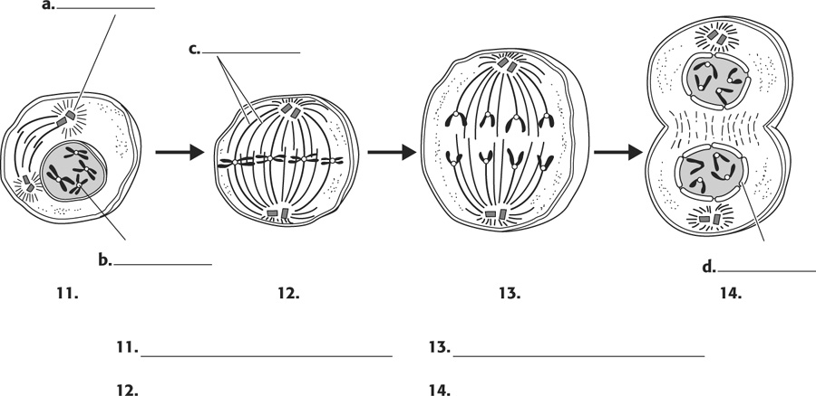

\

___________________________
___________________________
23.
22.
21.
20.
23.
22.
21.
20.
Meiosis
The process that produces haploid gametes is meiosis. Meiosis is a type of cell division in which the number of chromosomes is reduced by half. It occurs only in certain special cells of the organisms. During meiosis, homologous chromosomes separate, and the haploid cells that form have only one chromosome from each pair. Two cell divisions occur during meiosis, and a total of four haploid cells are produced. The two cell divisions are called meiosis I and meiosis II.

Phases of Meiosis
Meiosis I begins after DNA replicates during interphase. In both meiosis I and meiosis II, cells go through the same four phases as mitosis. However, there are important differences between meiosis I and mitosis.

Meiosis I
- Prophase I: The nuclear envelope begins to break down, and the chromosomes condense. Centrioles start moving to opposite poles of the cell, and a spindle begins to form. Importantly, homologous chromosomes pair up, which is unique to prophase I. In prophase of mitosis and meiosis II, homologous chromosomes do not form pairs in this way.
- Metaphase I: Spindle fibers attach to the paired homologous chromosomes. The paired chromosomes line up along the equator the cell. This occurs only in metaphase I. In metaphase of mitosis and meiosis II, it is sister chromatids that line up along the equator the cell.
- Anaphase I: Spindle fibers shorten, and the chromosomes of each homologous pair start to separate from each other. One chromosome of each pair moves toward one pole of the cell, and the other chromosomes moves toward the opposite pole.
- Telophase I and Cytokinesis: The spindle breaks down, and the new nuclear membranes form. The cytoplasm of the cell divides, and two haploid daughter cell result. The daughter cells each have a random assortment of chromosomes, with one from each homologous pair. Both daughter cells go on to meiosis II.
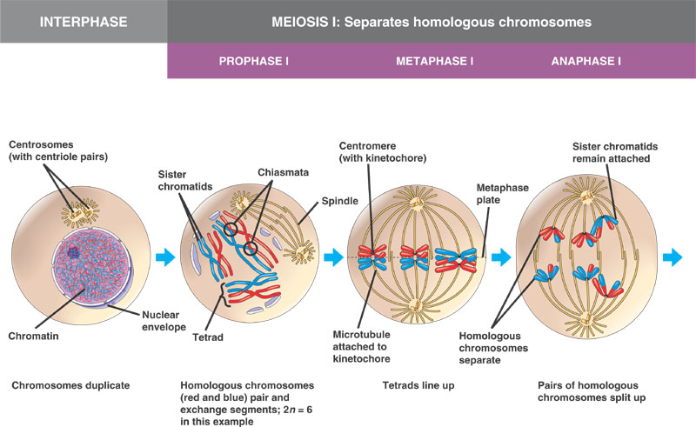

Match each statement with the stage of meiosis I it describes by writing in the spaces provided. The choices are: Prophase I, Metaphase I, Anaphase I, and Telophase I.

- ________________Cytoplasm divides
- ________________Nuclear envelope breaks down
- ________________Homologous chromosomes separate
- ________________Spindle moves homologous chromosomes to the cell’s equator
- ________________Crossing-over occurs
- ________________Two new cells form
- ________________Homologous chromosomes move to opposite poles of the cell
- ________________Chromosomes condense

Meiosis II
- Prophase II: The nuclear envelope breaks down and the spindle begins to form in each haploid daughter cell from meiosis I. The centrioles also start to separate.
- Metaphase II: Spindle fibers line up the sister chromatids of each chromosome along the equator of the cell.
- Anaphase II: Sister Chromatids separate and move to opposite poles.
- Telophase II and Cytokinesis: The spindle breaks down and the new nuclear membranes form. The cytoplasm of each cell divides, and four haploid cells result. Each cell has a unique combination of chromosomes.
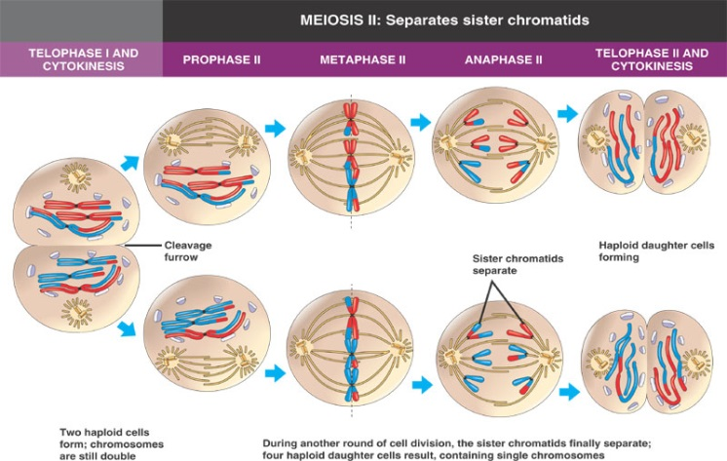

Match each statement with the stage of meiosis II it describes by writing in the spaces provided. The choices are: Prophase II, Metaphase II, Anaphase II, and Telophase II.

- ________________Centromeres divide
- ________________New spindle fibers form
- ________________Cell undergoes cytokinesis
- ________________Chromosomes line up at the equator
- ________________Spindle breaks down
- ________________Chromosomes move to opposite poles of the cell
- ________________Four haploid cells form

Use both the readings from Meiosis I and Meiosis II to answer the questions.

- Define meiosis.
- Is the DNA replicated after meiosis I? Why or why not?
- Describe the main difference between metaphase I and metaphase II.
- What is the final product of meiosis?

