3:6 The Plasma Membrane
- Organisms must adjust to changes in their environment.
- Living cells maintain a balance by controlling materials that enter and leave. This is accomplished by the CELL MEMBRANE, which is selectively permeable.

SELECTIVELY PERMEABLE: membrane that allows some materials to pass through (water glucose, nutrients) while keeping others out (wastes).
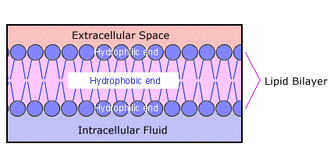

Structure of the Cell Membrane
- It is a BILAYER, a structure made up of 2 layers.
- Each layer is made up of a sheet of lipid (fat) molecules.
- Protein molecules are embedded in the lipid bilayers.
- help to move large molecules
- attached on the surface
- Heads contain glycerol and a phosphate are HYDROPHILLIC (“water” “loving”)
- Tails are made of two fatty acids and are HYDROPHOBIC (“water” “fearing”)

