Biology Unit 4 Energy and Life

4:1 Energy

All living things require a constant supply of ENERGY.

AUTOTROPH: organisms that make their own food

HETEROTROPH: obtain energy from the food they consume

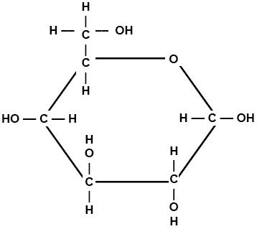

GLUCOSE: (C6H12O6) the form of energy used for fuel by ALL living cells

It requires energy to form chemical bonds, that energy is released when bonds are broken.

PHOTOSYNTHESIS: series of chemical reactions during which PLANTS change light energy from the sun into chemical energy stored in the chemical bonds of GLUCOSE molecules

CELLULAR RESPIRATION: process of chemical changes carried out by ALL LIVING THINGS that releases energy by breaking the chemical bonds in GLUCOSE

Photosynthesis occurs only in certain green plant cells. Respiration occurs in all cells of all living things.

Photosynthesis and respiration are OPPOSITE REACTIONS!

Only those organisms that carry out photosynthesis can make their own food.

All other organisms rely on these organisms for food.

MATTER (atoms and molecules) CAN BE RECYCLED.

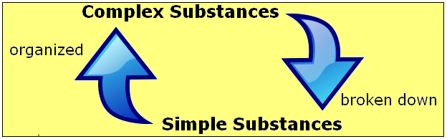



ENERGY IS NOT RECYCLED! A constant supply of energy is needed to organize simple substances into complex substances.

4:2 ATP – The Energy Transfer Compound

During photosynthesis, light enters the cell too rapidly to be stored as glucose. In respiration, energy must be released in controlled amounts.

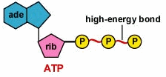ADENOSINE TRIPHOSPHATE: (ATP) energy transfer compound used to trap energy and release it in controlled amounts to meet the needs of living cells.

Structure of ATP 🡪 ATP consists of

* ADENOSINE a nitrogen base (ADENINE) bonded to a sugar (RIBOSE)
* Three PHOSPHATE GROUPS are bonded to adenosine

To Make ATP 🡪

1. First phosphate bonded to Adenosine makes Adenosine MonoPhosphate (AMP)

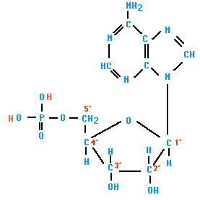

Adenine

Ribose

Phosphate group

1. Second phosphate bonded to AMP by a HIGH ENERGY BOND makes Adenosine DiPhosphate (ADP)

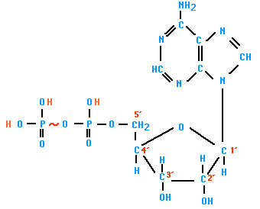

Adenine

Ribose

## 2 Phosphate groups

1. Third phosphate bonded to ADP by a HIGHER ENERGY BOND to form Adenosine TriPhosphate

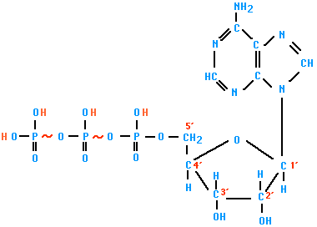

Adenine

Ribose

3 Phosphate groups

The last higher energy bond is the key to storage, transfer, and release of energy by ATP.

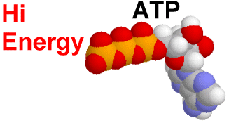ATTACHING 3rd PHOSPHATE – ADP🡪ATP – requires energy – energy STORED in the last higher energy bond.

# ADP + phosphate + energy 🡪 ATP

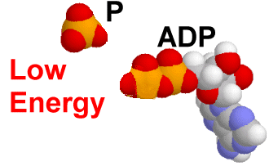REMOVING 3rd PHOSPHATE – ATP🡪ADP – releases energy – energy RELEASED by breaking the last highest energy bond.

ATP 🡪 ADP + phosphate + energy

