4:5 Cellular Respiration

OXIDATION: the release of energy from a substance accomplished by adding oxygen or removing hydrogen

OXIDATION is a sudden release of energy. CELLULAR RESPIRATION is a controlled process that releases energy in a series of steps.

### mitochondriadrawingOverview of Cellular Respiration

* GLUCOSE is oxidized.
* ENERGY released from glucose used to change ADP to ATP.
* CO2 and H2O are given off.

GLYCOLYSIS: first step of cellular respiration; one molecule of glucose is broken in half, producing two molecules of pyruvic acid, a 3-Carbon compound

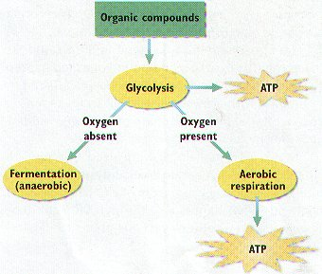

Glycolysis is followed by ONE of three different processes: alcohol fermentation, lactic acid fermentation, or the Krebs cycle.

In the presence of oxygen, pyruvic acid produced in glycolysis passes to the second stage of cellular respiration, the KREBS CYCLE.

Overview of the Krebs Cycle

1. Pyruvic acid produced by glycolysis enters the mitochondria. CO2 is released and a 6-carbon molecule called citric acid is produced.
2. As the cycle continues, critic acid is broken down into a 4-carbon molecule, more COs is released, and electrons are transferred to energy carriers, then to the Electron Transport Chain.

Overview of the Electron Transport Chain

1. 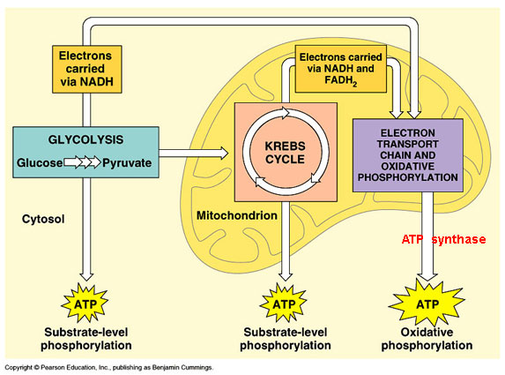NADH and FADH2 give electrons to the ETC.NADH donates electrons at the beginning, and FADH2 donates them farther down the chain. These molecules give up protons.
2. Electrons are passed down the chain. As they move, they lose energy.
3. The energy lost from the electrons is used to pump protons from the matrix, building a high concentration of protons between the inner and outer membranes. A concentration gradient and electrical gradient are created.
4. The concentration gradients of protons drive the synthesis of ATP.
5. Oxygen is the final acceptor of electrons that have passed down the chain. Oxygen accepts protons that were part of the hydrogen atoms supplied by NADH and FADH2. The protons, electrons, and oxygen all combine to form water.

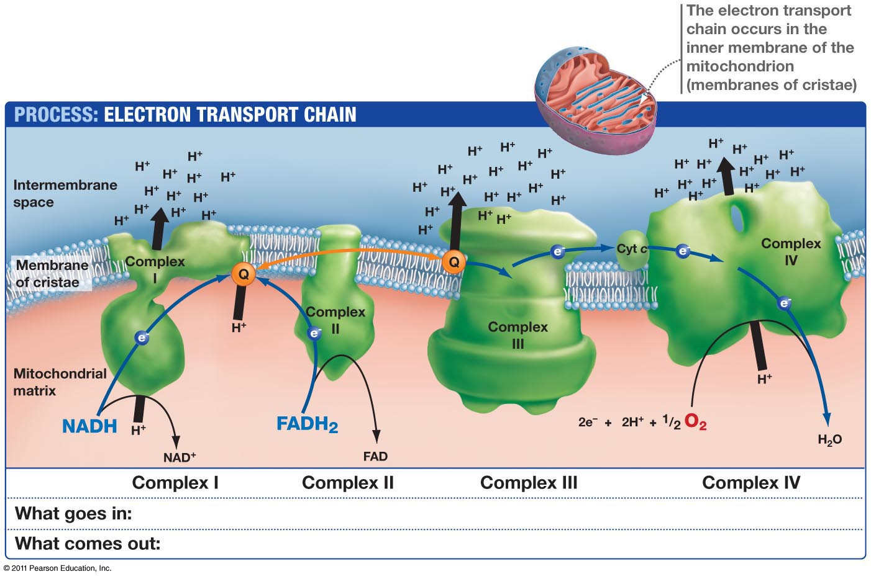

### Chemical Equation for Cellular Respiration

C6H12O6 + 6 O2 🡪 6 CO2 + 6 H2O + 38 ATP

38 ATP is only 60% of the energy in one glucose; the other 40% is lost as heat.

