5:3 DNA Shape and Structure

Shape of DNA
DNA is a DOUBLE HELIX: twisted ladder

The weakest part of the DNA ladder is the middle of the rungs, where DNA will split.

Structure of DNA
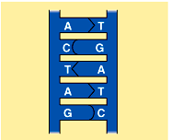
- The sides of the DNA ladder are made of alternating phosphate groups and sugar (pentose) groups
- Each deoxyribose has a nitrogen-containing base attached. There are 4 bases possible adenine, thymine, cytosine, and guanine.
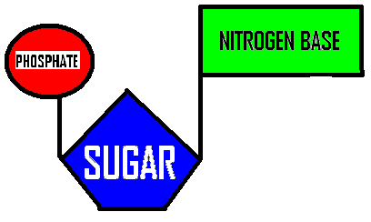
- Each nucleotide is a single 3-part unit consisting of 1 deoxyribose, 1 phosphate group, and 1 nitrogen-containing base.
- Two strands of nucleotides bond together by their bases to form a DNA molecule. A will only bond to T, G will only bond to C. There are only two possible bonds A-T and G-C, called complementary base pairs. Nitrogen bases are bonded together by weak hydrogen bonds.

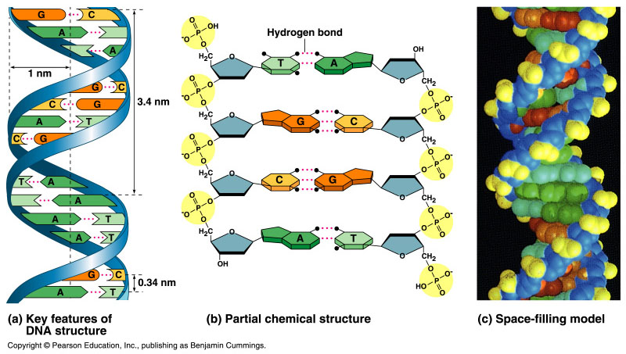

Nitrogenous Bases
PURINES: double ring of carbon and nitrogen atoms
- Adenine and Guanine
PYRIMIDINES: single ring of carbon and nitrogen atoms
- Thymine and Cytosine

Purines only pair with pyrimidines.

