5:7 Translation

TRANSLATION: process of decoding the mRNA into a polypeptide chain (protein)

Ribosomes
- Made of a large and small subunit
- Composed of rRNA and proteins

TRIPLET CODONS : group of 3 bases on a mRNA strand that act as a code word for a specific amino acid
The 4 RNA bases combine in 64 different triplet codons. Since there are only 20 amino acids, several codons code for the same amino acid, some code for the start or stop of a protein.
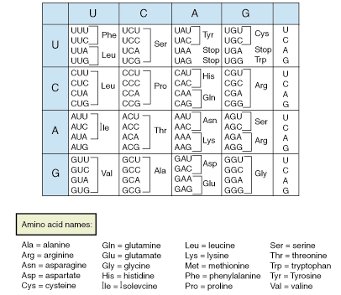
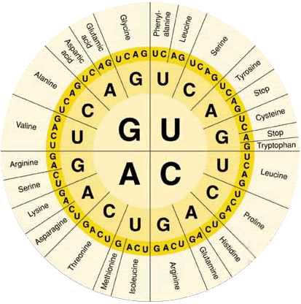

THE ORDER OF THE TRIPLET CODONS ON A STRAND OF mRNA CODES FOR THE ORDER OF AMINO ACIDS ON A PROTEIN CHAIN.

Steps of Translation
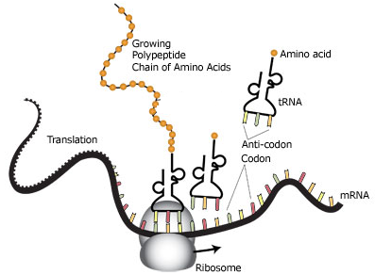
- mRNA transcript start codon AUG (Methionine) attaches to the small ribosomal subunit; small subunit attaches to large ribosomal subunit
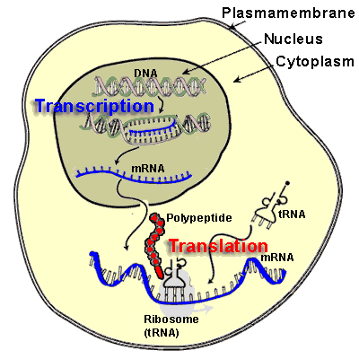
- The tRNA carrying the amino acid specified by the next codon binds to the codon. A peptide bond forms between adjacent amino acids. The ribosome moves the tRNA and mRNA.
- The first tRNA detaches and leaves its amino acid behind. The polypeptide chain continues to grow.
- The process ends when a stop codon is reached. A stop codon is one for which there is no tRNA that has a complementary anticodon.
- The ribosome complex falls apart. The newly made protein is released.

Ribosome can build only one protein at a time several ribosomes may work on one mRNA template. mRNA template may be used several times, then broken down and nucleotides reused.

