Types of Natural Selection
Name: __________________________________ Date: ____________________ Hour: _________

Define the following terms.

- Stabilizing Selection: ___________________________________________________________________
________________________________________________________________________________________________________________________________________________________________________
- Directional Selection: __________________________________________________________________
________________________________________________________________________________________________________________________________________________________________________
- Disruptive Selection: ___________________________________________________________________
________________________________________________________________________________________________________________________________________________________________________

Multiple Choice: Circle the correct answer for each of the questions below.
- In which of the following is variation reduced in the population:
  - Stabilizing Selection
  - Disruptive Selection
  - Directional Selection
  - None of the above.
- In which of the following are individuals of intermediate phenotypes are lost from the population?
  - Stabilizing selection
  - Disruptive selection
  - Directional selection
  - None of the above.
- Starlings produce on average of five eggs in each clutch. If there are more than five, the parents cannot adequately feed the young. If there are fewer than five, predators may destroy the entire clutch. This is an example of
  - Disruptive selection.
  - Stabilizing selection.
  - Directional selection.
  - None of the above.
- The occurrence of large or small beak sizes among seed crackers in the absence of medium-seized beaks is an example of
  - Directional selection
  - Stabilizing selection
  - Disruptive selection
  - None of the above
- A scientist measures the circumference of acorns in a population of oak trees and discovers that the most common circumference is 2 cm. what would you expect the most common circumferences to be after 10 generation of stabilizing selection?
  - 2 cm
  - Greater than 2 cm or less than 2 cm
  - Greater than 2 cm and less than 2 cm
  - Cannot tell from the information given

- Refer to question 8, but this time answer what you would expect after 10 generations of disruptive selection.
  - 2 cm
  - Greater than 2 cm or less than 2 cm
  - Greater than 2 cm and less than 2 cm
  - Cannot tell from the information given
- Refer to question 8, but this time answer what you would expect after 10 generations of directional selection.
  - 2 cm
  - Greater than 2 cm or less than 2 cm
  - Greater than 2 cm and less than 2 cm
  - Cannot tell from the information given
- For birds and parasitoids, females that lay close to the Lack optimum number of eggs have the most surviving offspring. Those that lay fewer or more eggs have lower relative fitness.
  - Stabilizing Selection
  - Disruptive Selection
  - Directional Selection
  - None of the above.
- If a cow develops a preference for eating white four o’ clock flowers and ignores the pink and red four o’clock flowers, what type of selection is being demonstrated?
  - Stabilizing Selection
  - Disruptive Selection
  - Directional Selection
  - None of the above.
- A population of Madagascar hissing cockroaches lives in a woodpile. It suffers heavy predation from lizards. Because their heads are small, the lizards are unable to eat the very largest adult cockroaches, and instead prey upon small and medium sized adults. What type of selection do the lizards impose on the roaches? Why do you think that?

Label the three types of selection illustrated below.

- __________________________
- __________________________
- __________________________
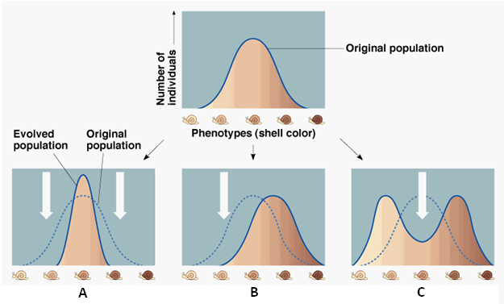

Use the figure below to answer questions.

- Describe what is happening in the picture. _________________________________________________________
______________________________________________________________________________________________________________________________________________________________________________________
- Is the population of mice different in picture 3 than in picture 1? _______________________________________
- Explain your answer for number 15. ______________________________________________________________
______________________________________________________________________________________________________________________________________________________________________________________
- Which mice in this population have the highest fitness? _____________________________________________
- What type of natural selection is occurring? _______________________________________________________
- Which population of mice will continue to reproduce? _______________________________________________
- Draw a graph to illustrate your answer.

