# Biology Unit 2 Matter, Energy, and Life

2:1 Matter and Energy

MATTER: anything that has mass and takes up space

### Three States (phases) of Matter

1. 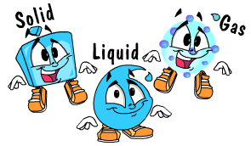SOLID: matter with definite volume and shape
2. LIQUID: matter with definite volume but no definite shape
3. GAS: matter with no definite volume nor shape

### How does Matter Change?

* + 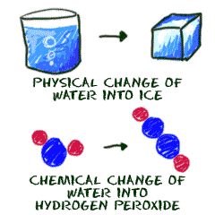PHYSICAL CHANGE: change in size, shape, or state of matter

e.g. changing wood boards into a chair

* + CHEMICAL CHANGE: change from one substance to another

e.g. wood burning

ELEMENT: substance that cannot be broken down to simpler substances by ordinary means

ATOM: smallest unit of an element with all the properties of that element

SYMBOL: shorthand way to represent one atom of an element

e.g. Hydrogen – H Sodium – Na

Oxygen – O Iron – Fe

Carbon – C Nitrogen – N

2:2 Structure of the Atom

### Areas in an Atom

1. 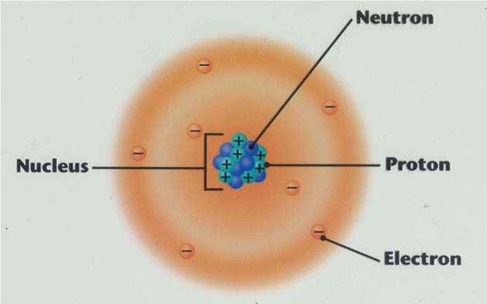NUCLEUS: positively charged center of an atom containing almost all the atomic mass
2. ELECTRON CLOUD: negatively charged area around the nucleus with almost no mass

# Atomic Particles

1. PROTON: positively charged particle in the nucleus, has mass (1 AMU)*
2. ELECTRON: negatively charged particle in the electron cloud, no mass
3. NEUTRON: neutral (no charge) particle in the nucleus, has mass (1 AMU)*

*AMU: Atomic Mass Unit

The charge of a proton (p+) is EQUAL and OPPOSITE to the charge of an electron (e-).

In ALL ATOMS the number of protons equals the number of electrons. ATOMS HAVE NO OVERALL ELECTRICAL CHARGE.

Elements are different because they have different numbers of protons and electrons than other elements.

ATOMIC NUMBER: the number of protons (or electrons) in one atom of an element

Atomic Number = # p+ = #e-

ATOMIC MASS NUMBER: the number of protons PLUS the number of neutrons in an atom of an element

Atomic Mass Number = # p+ + # n

# n = Atomic Mass Number - # p+

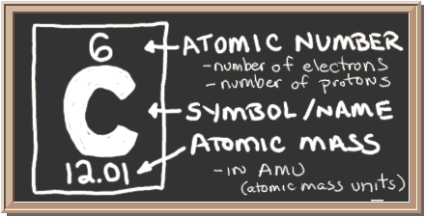

Always round the Atomic Mass to the nearest whole number.

ISOTOPES: atoms of the same element (same atomic #) with different numbers of neutrons (different atomic mass)

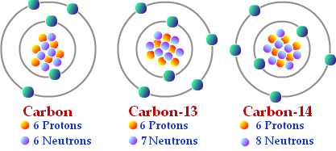

ATOMIC MASS UNIT: (AMU) unit used to measure mass of atoms and atomic particles

1 AMU = mass of 1 p+ = mass of 1 n

ENERGY LEVELS: paths that electrons follow around the nucleus 1st EL- holds 2 e- or 1 pair

2nd EL- holds 8 e- or 4 pairs

3rd EL – holds 8 e- or 4 pairs

Inner ELs must be full before next EL begins to fill. All atoms want full OEL(outer energy level).

* + 2 in 1st
  + 8 in 2nd
  + 8 in 3rd

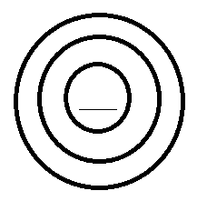

2:3 Compounds

COMPOUND: substance in which two or more elements are combined chemically

MOLECULE: smallest unit of a compound with all the properties of the compound

FORMULA: shorthand way to represent one molecule of a compound

SUBSCRIPT: number representing the number of atoms of an element in one molecule of a compound

example H2O 2 atoms of Hydrogen

1 atom of Oxygen

formula for 1 molecule of water

Facts About Making Compounds

1. Under certain conditions, most elements will chemically combine with other elements.

CHEMICALLY ACTIVE: elements that will chemically combine

INERT: elements with almost no chemical activity due to full outer energy levels

1. Each element has its own combining capacity.
2. In forming compounds, elements combine in definite proportions
3. A compound has different properties than the element of which it is made.

2:4 Energy

ENERGY: the ability to do work or cause change

# Two Types of Energy

1. KINETIC ENERGY: energy of motion, energy actually doing work or causing change
2. POTENTIAL ENERGY: energy of position, stored or chemical energy

Energy may change from one form to another.

ACTIVATION ENERGY: energy needed to begin the change from potential energy to kinetic energy

LAW OF CONSERVATION OF MATTER AND ENERGY: matter and energy cannot be created nor destroyed but may be changed from one form to another

CATALYST: chemical substance that can reduce the amount of activation energy needed to start a reaction

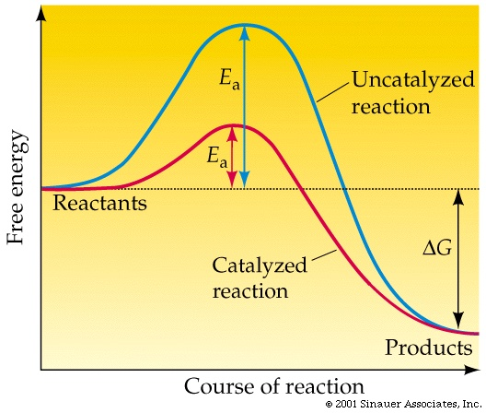

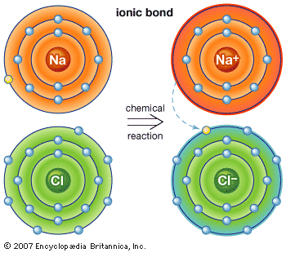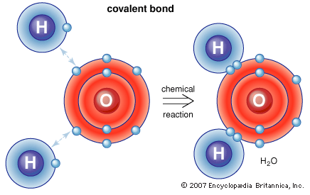

2:5 Chemical Bonding

CHEMICAL BOND: force holding elements (atoms) together to form compounds (molecules)

Elements form bonds to fill their Outer Energy Levels.

Two Types of Chemical Bonds

1. COVALENT BOND: bond formed when two atoms share electrons in their OEL, electrons orbit nuclei of both atoms
2. IONIC BOND: bond due to electrical attraction of two atoms which have transferred electrons from one to the other

ION: atoms which carry + or – electrical charge due to loss or gain of electrons

example Na→e- donor→Na+

Cl→e- acceptor→Cl-

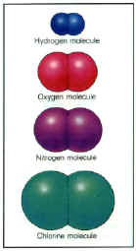NaCl→salt→held together by IONIC BOND→the attraction of oppositely charged ions

DIATOMIC MOLECULE: compound formed when two atoms of the same element covalently bond

examples H2 O2 N2 Cl2

2:6 Water and Solutions

Water is a polar molecule.

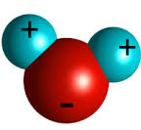POLAR: uneven distribution of charge

They do not share electrons equally, so Hydrogen and Oxygen have charged poles. H is slightly positive and O is slightly negative.

PROPERTIES OF WATER:

1. COHESION: water molecules stick to each other as a result of attractive forces between hydrogen bonds
   1. Example: how water has the ability to travel from roots to the leaves
2. 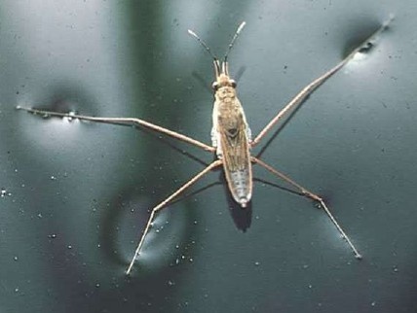ADHESION: attractive forces between two particles of different substances, such as water and glass
   1. 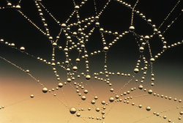Example: Insects on the surface of water
3. 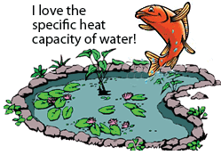HIGH HEAT CAPACITY: absorb and release large amounts of energy without change in temperature
   1. Example: Earth’s oceans stabilize global temperatures enough to allow life to exist
4. SOLVENT: fluid that dissolves solutes
   1. Example: Because water is polar it has the ability to dissolve a large number of substances (proteins, sugars, etc)
   2. Oxygen and Carbon Dioxide dissolve in water in the blood and then carry to different parts of the body
5. DENSITY OF ICE-solid water is less dense than liquid water
   1. EXTREMELY IMPORTANT! Bodies of water freeze from the top down and not the bottom up.

Write 1-2 sentences explaining what the effect would be if water froze from the bottom up. ____________________________________________________________________________________

Water has CAPILLARITY: attraction of molecules that results in the rise of the surface of a liquid when in contact with a solid (straws, plant roots)

Solutions

SOLUTION: mixture in which one or more substances are uniformly distributed in another substance

SOLUTE: substance being dissolved

SOLVENT: substance that dissolves the solute

CONCENTRATION: amount of solute dissolved in a fixed amount of the solution

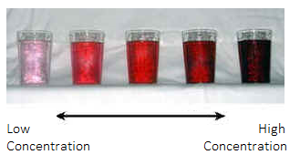Using a lot of Kool-Aid mix will make your Kool-Aid taste stronger because it would be highly concentrated.

2:7 Acids, Bases, and the pH Scale

ACIDS: ionic compounds that break apart in water to form positively charged hydrogen ions (H+)

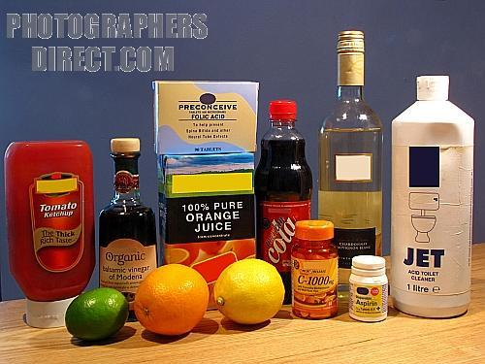Examples – Vinegar, Citrus Fruits, Stomach Acid

(Hydrochloric Acid)

* The strength of an acid is determined by the concentration of hydrogen ions (H+) in the solution.
* The more H+ ions the stronger the acid.

Characteristics of Acids:

* Acids taste sour
* Acids react strongly with metals (Zn + HCl)
* Strong Acids are dangerous and can burn your skin

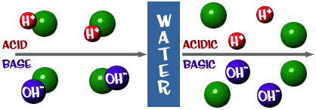

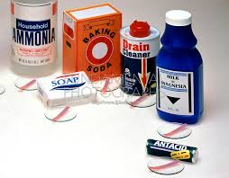BASES: ionic compounds that break apart in water to form negatively charged hydroxide ions (OH-)

Examples – Ammonia, Lye (Sodium Hydroxide)

* The strength of a base is determined by the concentration of Hydroxide ions (OH-) in the solution.
* The more OH- ions the stronger the base.
* Solutions containing bases are often called alkaline.

Characteristics of Bases

* Bases taste bitter and feel slippery
* Strong bases are very dangerous and can burn your skin

pH SCALE: a scale that measures the strength of an acid or base in a solution

* The pH scale is a measure of the hydrogen ion concentration.
* It spans from 0 to 14 with the middle point pH 7 being neutral, neither acidic nor basic.
* pH number **GREATER** than 7=base
* pH number **LESS** than 7=acid
* 0 is the strongest acid and 14 is the strongest base.

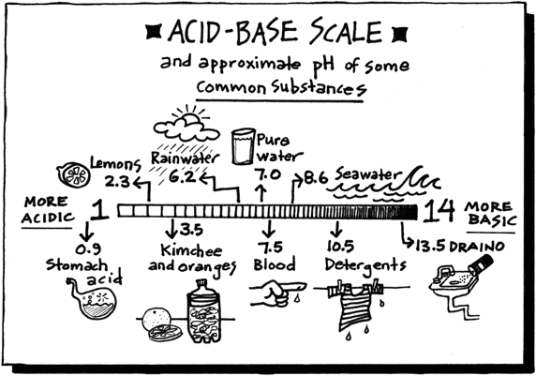

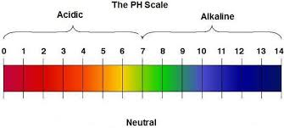

INDICATOR: a special type of compound that changes color as the pH of a solution changes, thus indicating the pH of the solution

BUFFER: chemical substances that neutralize small amounts of acids or bases (bringing the pH closer to 7)